OPTIMIZING PEROVSKITE SOLAR CELL PERFORMANCE


JULY 2024 - DECEMBER 2024
MINOR PROJECT -1 (15B19EC591)
Submitted By:

Nishant Dwivedi | 22102004
Vibhor Yadav | 22102005
Priyanshu Agrawal | 22102236

Submitted To: Dr. Rishibrind Upadhyay Submitted in partial fulfillment of the Degree of Bachelor of Technology
DEPARTMENT OF ELECTRONICS AND COMMUNICATION ENGINEERING
JAYPEE INSTITUTE OF INFORMATION TECHNOLOGY, NOIDA

CERTIFICATE
This is to certify that the work titled “OPTIMIZING PEROVSKITE SOLAR CELL PERFORMANCE” submitted by “NISHANT DWIVEDI (Enrolment No- 22102004)”
,“VIBHOR YADAV (Enrolment No- 22102005)”, “PRIYANSHU AGARWAL
(ENROLMENT NO - 22102236)” in partial fulfillment for the award of degree of B.TECH of Jaypee Institute of Information Technology, Noida has been carried out under my supervision. This work has not been submitted partially or wholly to any other University or Institute for the award of this or any other degree or diploma.

Dr. Rishibrind Upadhyay Designation:
Date:

ACKNOWLEDGEMENT
We would like to express our heartfelt gratitude to all those who supported and guided us throughout the completion of our project on Optimizing Perovskite Solar Cell Performance.First and foremost, we extend our deepest thanks to our supervisor, Dr. Rishibrind Upadhyay, for his invaluable guidance, encouragement, and insightful feedback. His expertise and unwavering support were instrumental in shaping the direction of our research and ensuring the successful completion of this project.We are also deeply grateful to the library staff and resources at Jaypee Institute of Information Technology, Noida, for providing access to relevant books, journals, and simulation software, which were crucial for our exploration of perovskite solar cell optimization.A special thanks to each member of our group for their dedication, collaboration, and valuable contributions. The collaborative efforts and discussions during the course of this project greatly enriched our understanding and led to meaningful outcomes.Finally, we acknowledge the authors, researchers, and scientists whose published works provided the foundational knowledge and technical insights required for our project. Their contributions to the field of solar cell technology inspired us and played a pivotal role in guiding our research endeavours.This project would not have been possible without the collective support, resources, and encouragement from these individuals and institutions, and we are sincerely grateful to each one of them.

Signature of the students Nishant Dwivedi Priyanshu Agarwal Vibhor Yadav
Date –

CANDIDATE’S DECLARATION

We hereby declare that the project report titled “OPTIMIZING PEROVSKITE SOLAR CELL PERFORMANCE” submitted to Jaypee Institute of Information Technology, Noida, in fulfillment of the requirements for the degree of Bachelor of Technology in Electronics and Communication Engineering, is a record of our original work carried out during a period from JULY 2024 to DECEMBER 2024 under the guidance of Dr. Rishibrind Upadhyay.
We further declare that the project has been completed successfully and the results presented are based on our work. This report has not been submitted to any other university or institution for the award of any degree or diploma.
We also affirm that the work presented in this report is authentic and has been performed by us to the best of our knowledge and abilities.
Student Signatures:

Name | Enrolment Number | Signature
Nishant Dwivedi | 22102004
Vibhor Yadav | 22102005
Priyanshu Agrawal | 22102236
This is to certify that the above statement made by the candidates is correct to the best of my Knowledge.

Supervisor’s Signature:

Dr. Rishibrind Kumar Upadhyay Assistant Professor (Senior Grade)
Department of Electronics and Communication Engineering

Date: [16 November ,2024]

Place: Noida, India

ABSTRACT

This paper presents a comprehensive numerical simulation study of high-performance perovskite solar cells (PSCs) using SCAPS-1D, focusing on optimizing structural parameters to enhance efficiency while addressing critical environmental challenges. The research investigates both lead-based and lead-free perovskite materials, targeting the reduction of toxicity and environmental hazards associated with lead usage in photovoltaic technology.
For lead-based perovskites, a CH₃NH₃Pb(I₁₋ₓClₓ)₃ absorber was analyzed in an inverted structure (FTO/ZnO/CH₃NH₃Pb(I₁₋ₓClₓ)₃/PEDOT/Au). Simulation results yielded a power conversion efficiency (PCE) of 24.98%, with a fill factor (FF) of 85.19%, a short-circuit current density (Jsc) of
23.32 mA/cm², and an open-circuit voltage (Voc) of 1.257 V.

For lead-free alternatives, a CH₃NH₃SnBr₃ perovskite was studied with various hole transport layers (HTLs) such as Spiro-MeOTAD, PEDOT, NiO, CuO, and Cu₂O, and electron transport layers (ETLs) including TiO₂, ZnO, and Zn(O,S). An optimized configuration (FTO/ZnO/CH₃NH₃SnBr₃/Spiro-MeOTAD/Au) achieved a PCE of 27.26%, Voc of 1.019 V, Jsc of
32.47 mA/cm², and FF of 82.37%.

Furthermore, the study evaluates Cs₂TiBr₆ as a lead-free perovskite absorber in an Au/CuAlO₂/Cs₂TiBr₆/ZnO/FTO structure, achieving a PCE of 19.53%, Voc of 1.1231 V, Jsc of 23.54 mA/cm², and FF of 73.86%. These results highlight the potential of lead-free perovskite materials to mitigate environmental risks while maintaining competitive performance.
The research emphasizes the urgent need to transition from lead-based to lead-free perovskite technologies, minimizing environmental contamination and health risks without compromising efficiency. These advancements pave the way for environmentally sustainable and high-efficiency PSCs, addressing the dual challenges of energy demand and ecological conservation.

Signature of Student Signature of Supervisor

Nishant dwivedi Dr. Rishibrind Upadhyay

Vibhor yadav Priyanshu agarwal Date –

TABLE OF CONTENTS

- Introduction

  - Background 8
  - Objectives of the Project 11
  - Scope and Significance 18
  - Project Outline 20
- Literature Review
  - Evaluation and Development of Perovskite Solar Cells 21
  - Challenges in Perovskite Solar Cell Development 21
  - Optimization of Charge Transport Layers(CTLs) 21
- Materials and Methodology
  - Data Collection and Preprocessing 23
  - Theoretical Concept 23
  - Solar Cell Performance Evaluation 24
  - Device Structure and Layer Composition(CH₃NH₃Pb(I₁₋ₓClₓ)₃) 25
  - Device Structure and Layer Composition(CH₃NH₃SnBr₃) 29
  - Device Structure and Layer Composition(Cs₂TiBr₆) 32
- Results and Discussion
  - Impact of Material Properties on Solar Cell Performance 36
  - Lead-Based Perovskite Solar Cell Performance Result 38
  - Lead-Free Perovskite Solar Cell Performance Result (CH₃NH₃SnBr₃) 39
  - Lead-Free Perovskite Solar Cell Performance Result (Cs₂TiBr₆) 40
  - Effect of Temperature and Absorber Thickness on Performance 41
  - Graphs 42
  - Simulation Results 48
- Conclusion
  - Summary of Findings 54
  - Contributions of the Project 54
  - Future Work and Recommendations 54

- References

INTRODUCTION

Background
A solar cell and a photovoltaic (PV) cell refer to the same thing: a device that converts light energy into electrical energy through the photovoltaic effect. However, the term "solar cell" is typically used when talking about cells designed to harness sunlight specifically, while "PV cell" is the more technical or formal term used in the broader context of converting light (from any source, not just sunlight) into electricity.

Solar Cell:
    - Function: A solar cell is a semiconductor device that converts light energy, usually from the sun, into electricity. This conversion process is known as the photovoltaic effect.
    - Components: Most solar cells are made from semiconductor materials like silicon. When light hits the solar cell, it excites electrons in the material, creating electron-hole pairs. These pairs are separated by an electric field, and the movement of electrons creates an electric current.
    - Applications: Solar cells are primarily used in solar panels to generate electricity for homes, businesses, and even large-scale solar farms.

PV Cell (Photovoltaic Cell):
    - Photovoltaic means "light-electric," and refers to the process of converting light into electricity. So, a PV cell is simply another term for a solar cell.
    - Function: The working principle is the same — it generates electricity when exposed to light, typically sunlight.
    - Materials: Like solar cells, PV cells are typically made from silicon, but can also be made from other materials such as thin-film (e.g., cadmium telluride) or perovskite materials.
The rising global population has led to an increasing demand for energy, heavily reliant on fossil fuels over recent decades. However, as fossil fuel resources dwindle and their environmental impact grows, there is a notable shift toward renewable energy, particularly solar energy harnessed via the photovoltaic (PV) effect. Solar photovoltaics directly convert sunlight into electricity, with materials like silicon and, more recently, perovskites playing pivotal roles. In recent years, extensive research has turned to perovskite materials as an innovative solution, showing promise as efficient alternatives to conventional materials used in PV cells.

The Rise of Silicon Solar Cells
The journey from silicon (Si)-based solar cells to perovskite solar cells represents a significant evolution in photovoltaic (PV) technology, driven by the desire for more efficient, cost-effective, and versatile solar energy solutions. Here’s an overview of this journey:
  - Early Beginnings (1950s): Silicon-based solar cells were developed in the 1950s, marking the birth of modern photovoltaics. The first silicon solar cell was created at Bell Labs in 1954, achieving an efficiency of about 6%, which was groundbreaking at the time. These cells quickly found applications in space exploration due to their reliability and durability.
  - Efficiency Improvements (1960s-1990s): Over the next few decades, advances in silicon technology led to significant increases in efficiency, reaching over 20%. During this time, manufacturing processes improved, and silicon emerged as the dominant material for solar cells. By the 1990s, silicon solar cells had become widely used in terrestrial applications.
  - Maturity and Market Dominance (2000s-Present): Silicon solar cells continued to improve in terms of efficiency and cost. By the 2000s, monocrystalline and polycrystalline silicon solar cells achieved efficiencies between 15-24%, and the cost per watt began to fall significantly. Today, silicon solar cells make up more than 90% of the global PV market due to their stability, established manufacturing infrastructure, and reliability.

Challenges with Silicon Solar Cells
  - Cost and Material Limitations: Despite silicon's dominance, there are limitations, including the high energy required to purify silicon, the cost of manufacturing, and its relatively high material thickness requirements. Silicon solar cells also have a practical efficiency ceiling, known as the Shockley-Queisser limit, of about 29%.
  - Stagnant Efficiency Gains: While silicon PV cells have matured, significant efficiency gains became increasingly challenging due to the material’s physical properties. Researchers began exploring new materials and cell architectures to push beyond silicon’s limitations.

Emergence of Thin-Film Technologies
  - Introduction of Alternatives: In the quest to develop cheaper and lighter PV materials, thin-film solar technologies emerged, including cadmium telluride (CdTe), copper indium gallium selenide (CIGS), and amorphous silicon. These offered advantages in terms of lower material costs and flexibility, allowing applications on a variety of surfaces. However, issues like toxicity (CdTe) and resource scarcity (indium in CIGS) limited their widespread use.
  - Organic Photovoltaics (OPVs): Organic materials were also explored for PV cells due to their flexibility, low cost, and potential for large-scale manufacturing. While

promising, OPVs suffered from low efficiencies and short lifespans, making them less practical for mainstream applications.

The Discovery of Perovskite Materials
  - Initial Exploration (2009): In 2009, researchers led by Tsutomu Miyasaka used organometal halide perovskites as sensitizers in dye-sensitized solar cells, achieving an initial efficiency of 3.9%. This discovery sparked widespread interest due to perovskite materials' unique light-absorbing and charge-transport properties.
  - Rapid Efficiency Gains (2010s): Within a few years, perovskite solar cells (PSCs) achieved efficiencies exceeding 20%, rivaling those of silicon. The simple fabrication techniques, such as solution processing, allowed researchers to easily experiment and optimize PSCs, leading to unprecedented gains. By 2016, efficiencies had already surpassed 22%, marking one of the fastest efficiency advancements in PV history.

Advantages and Promises of Perovskite Solar Cells
  - Low-Cost Production: Perovskite materials can be produced using solution-based techniques at low temperatures, unlike silicon, which requires high-temperature processing. This lowers the production cost and offers potential for large-scale, printable PV devices.
  - High Absorption Coefficient and Tunable Bandgap: Perovskites have a high absorption coefficient, meaning they can absorb sunlight efficiently even in thin layers. Additionally, their bandgap can be tuned by altering the chemical composition, enabling applications like tandem solar cells and flexible PV solutions.
  - Lightweight and Flexible Applications: Because they can be produced as thin films, perovskites can be applied to flexible substrates, paving the way for innovative applications in wearable electronics, building-integrated PV, and portable solar devices.

7. Background on Perovskite Solar Cells (PSCs)
Perovskite solar cells (PSCs) have shown groundbreaking potential in the field of photovoltaics (PV), standing out as one of the most innovative and rapidly evolving technologies in solar energy. The advent of PSCs dates back to 2009, when Kojima et al. introduced the concept of using organometal halide perovskites as light-absorbing materials, achieving an initial efficiency of 3.9%. This pioneering achievement opened up a new avenue for PV materials that could challenge the dominance of silicon-based solar cells. Since then, PSC technology has made remarkable strides, achieving efficiencies that have soared to 22.7% in just a decade. This rapid growth is notable as it took traditional silicon solar cells much longer to achieve comparable efficiency milestones. The unique advantages of PSCs—such as their potential for high power conversion efficiency (PCE), low production costs, and ease of fabrication through solution-based processes—have positioned them as highly competitive alternatives to conventional PV technologies.

Objectives of the Project
In this study, we aimed to enhance the power conversion efficiency (PCE) of perovskite solar cells (PSCs) by systematically optimizing the materials and parameters of the various layers using SCAPS-1D simulation software. The primary focus was on achieving performance improvements by adjusting the properties of electron transport layers (ETLs) and hole transport layers (HTLs) while maintaining the perovskite absorber.

LEAD BASED PSCs
Organic-inorganic halide perovskites exhibit unique properties that position them as highly promising for solar applications. These include remarkable charge carrier mobility, low exciton binding energy, high absorption coefficients, tunable band gaps, extended diffusion lengths, and ease of synthesis. As alternatives to traditional silicon-based solar cells, perovskite solar cells (PSCs) have captivated the scientific community with their potential for low-cost, high-efficiency energy conversion. PSCs have demonstrated efficiencies over 25% in lab settings, putting them on par with traditional silicon cells. Among the various perovskite materials explored,methylammonium lead halide (CH₃NH₃Pb(I₁₋ₓClₓ)₃) has emerged as a particularly promising compound. By modifying the halide composition—specifically using a mixture of iodide (I) and chloride (Cl) in precise proportions—researchers have achieved enhanced stability, tuning the bandgap, carrier diffusion length, and crystalline phase properties. These modifications have led to PSCs with power conversion efficiencies (PCEs) exceeding 25%, a milestone achieved in a relatively short research period.
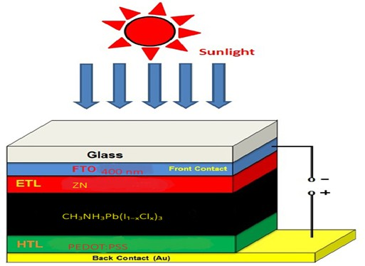

Fig. 1 (a): Device architecture of n-i-p perovskite solar cell.

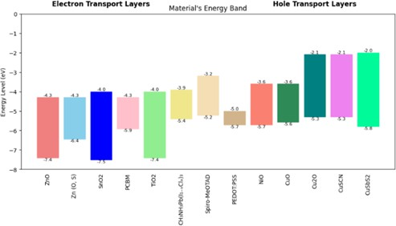

Fig. 1 (b): Energy band diagram of CH₃NH₃Pb(I₁₋ₓClₓ)₃, electron transport layers (ETLs), and hole transport layers (HTLs).

Challenges in PSC Stability
Despite the rapid efficiency gains, PSCs still face challenges related to stability, particularly under real-world conditions. Recent research efforts have increasingly focused on tackling these stability issues:
- Environmental Degradation: Perovskites are prone to degradation when exposed to environmental factors like moisture, oxygen, and heat. A notable development in this area has been the incorporation of iodide ions within formamidinium-lead-halide-based perovskites, which helps to stabilize the perovskite structure against humidity and thermal degradation. This approach addresses one of the primary limitations of PSCs, making them more robust for practical applications.
- Structural Modifications: To further enhance stability, researchers have developed mixed-cation and mixed-anion compositions that bolster the resilience of perovskites against thermal and photochemical stresses. By replacing or combining ions within the crystal lattice, these modifications have led to perovskite structures that can withstand the rigors of outdoor deployment, marking a significant step toward commercial viability for PSCs.

Limitations of Lead-Based PSCs
Despite the success of lead-based PSCs, concerns about the toxicity of lead present a significant barrier to large-scale adoption:
- Environmental and Health Risks: Lead is a toxic element with detrimental effects on both ecosystems and human health. While lead plays a vital role in achieving the desirable optoelectronic properties of perovskites, its use in PSCs poses risks of lead

leakage into the environment. Addressing these risks requires strict containment measures, which complicate the commercialization process.
- Organic Cation Instability: Another challenge in traditional PSCs is the use of organic cations, such as methylammonium, which contribute to chemical instability. These cations are susceptible to degradation upon exposure to moisture, which can compromise the long-term stability of PSCs. This limitation has led researchers to explore alternative compositions that could provide similar performance without the associated drawbacks.

Exploring Tin as an Alternative
Given the environmental and health challenges posed by lead, scientists have turned their attention to tin (Sn) as a potential substitute:
- Material Compatibility: Tin is an attractive alternative because it shares a similar electronic configuration and ionic radius to lead, which allows it to integrate into the perovskite crystal structure with minimal disruption. This substitution maintains the perovskite structure's favorable properties, such as high light absorption and efficient charge transport.
- Challenges with Tin-Based Perovskites: While promising, tin-based perovskites present their own set of challenges. Specifically, they are prone to oxidation, which can lead to the conversion of Sn²⁺ to Sn⁴⁺ in the presence of bromine ions. This oxidation process reduces the efficiency and stability of the device, necessitating further material engineering to mitigate these issues.

LEAD FREE PSCs (CH₃NH₃SnBr₃)
The current study seeks to overcome the challenges associated with tin-based PSCs by introducing CH₃NH₃SnBr₃ (methylammonium tin bromide) as the absorber layer in PSCs:

Primary Objectives:
  - Replace lead with tin to create a more environmentally friendly PSC that minimizes toxicity.
  - Optimize the power conversion efficiency (PCE) of CH₃NH₃SnBr₃-based PSCs through adjustments in device architecture and operating conditions.
  - Utilize SCAPS-1D simulation software for a detailed analysis of solar cell parameters, such as energy band diagrams, quantum efficiency, and current density. SCAPS-1D, developed by the University of Ghent, is widely used for simulating photovoltaic devices and provides valuable insights into device performance.

Advantages of Tin-Based Perovskites

Tin-based perovskites offer several advantages that make them promising candidates for high-performance PSCs:
- Structural Compatibility: The ionic radius of tin (Sn²⁺ at 0.93 Å) is close to that of lead (Pb²⁺ at 1.20 Å), allowing tin to fit within the perovskite crystal lattice without significant distortion. This compatibility preserves the semiconductor properties necessary for high-efficiency devices.
- Enhanced Charge Transport: Studies have shown that tin-based perovskites, like CH₃NH₃SnI₃, exhibit improved electron and hole mobility compared to their lead-based counterparts, facilitating efficient charge transport within the cell.
- Optimal Bandgap: CH₃NH₃SnBr₃ has a direct bandgap of approximately 1.3 to 1.4 eV, which falls within the ideal range for solar energy applications. Its high absorption coefficient further enhances its potential to capture sunlight effectively, making it a strong candidate for high-efficiency PSCs.

Research Approach

This study aims to optimize several key parameters to maximize the performance of CH₃NH₃SnBr₃-based PSCs:
- Focus Areas: Key parameters, such as absorber layer thickness, operating temperature, and the choice of electron and hole transport layers (ETL and HTL), are systematically varied to assess their impact on device efficiency.
- Device Architecture: The baseline configuration used in this study is the FTO/ZnO(ETL)/CH₃NH₃SnBr₃/Spiro-OMeTAD(HTL)/Au setup. Through SCAPS-1D simulations, the study explores how variations in each component influence photovoltaic metrics such as PCE, Voc, and Jsc, providing insights that inform precise adjustments for enhanced performance.

Temperature Sensitivity

Temperature variations play a significant role in PSC performance:

- Impact of Temperature: PSCs are sensitive to changes in operating temperature, with parameters like Voc, Jsc, and PCE being affected. Typically, higher temperatures increase carrier recombination rates and decrease charge mobility, leading to a reduction in Voc and overall device efficiency.
- Goal: By examining temperature dependencies, this study aims to design PSCs that can maintain stable performance across a range of environmental conditions.

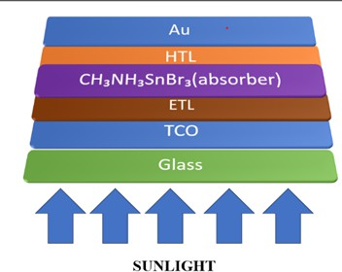

Fig.2 (a): Device architecture of n-i-p perovskite solar cell.

- Achievement: A peak efficiency of 27.26% was achieved with CH₃NH₃SnBr₃-based solar cells, showcasing the potential of tin-based perovskites as viable, sustainable materials for PV applications.
- Implication: The findings contribute valuable insights for developing lead-free PSCs, supporting global efforts toward environmentally responsible solar energy solutions that can drive the transition to a more sustainable energy future.
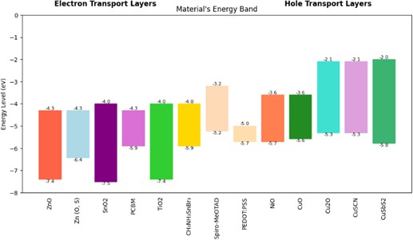

Fig. 2 (b): Energy band diagram of CH₃NH₃SnBr₃ electron transport layers (ETLs), and hole transport layers (HTLs).

LEAD FREE PSCs (Cs₂TiBr₆)
The current study seeks to overcome the challenges associated with lead-based perovskite solar cells (PSCs) by introducing Cs₂TiBr₆ as the absorber layer in lead-free PSCs. The primary objectives are to replace lead with titanium (Ti) and bromine (Br) to create a more environmentally friendly PSC that minimizes toxicity, and to optimize the power conversion efficiency (PCE) of Cs₂TiBr₆-based PSCs through adjustments in device architecture and operating conditions.
Advantages of Cs₂TiBr₆-Based Perovskites:
Cs₂TiBr₆-based perovskites offer several advantages that make them promising candidates for high-performance lead-free PSCs:
- Structural Compatibility: The ionic radius of titanium (Ti⁴⁺ at 0.605 Å) and bromine (Br⁻ at 1.96 Å) are suitable for integration into the perovskite crystal lattice without significant distortion. This compatibility helps maintain the semiconductor properties necessary for high-efficiency devices.
- Enhanced Stability: Cs₂TiBr₆-based perovskites exhibit enhanced chemical and thermal stability compared to traditional lead-based perovskites, making them more suitable for long-term use in solar cells.
- Bandgap Tuning: Cs₂TiBr₆ has a suitable bandgap that allows for efficient light absorption in the solar spectrum range of 2.0 to 2.3 eV. Its ability to be tuned for specific applications further enhances its potential as a sustainable alternative for high-efficiency PSCs

Research Approach:
This study aims to optimize several key parameters to maximize the performance of
Cs₂TiBr₆-based lead-free PSCs:

- Focus Areas: Key parameters, such as absorber layer thickness, operating temperature, and the choice of electron and hole transport layers (ETL and HTL), are systematically varied to assess their impact on device efficiency.
- Device Architecture: The baseline configuration used in this study is the FTO/(ETL)/Cs₂TiBr₆/(HTL)/Au setup. Through SCAPS-1D simulations, the study explores how variations in each component influence photovoltaic metrics such as PCE, Voc, and Jsc, providing insights that inform precise adjustments for enhanced performance.

Temperature Sensitivity:
Temperature variations play a significant role in PSC performance:

- Impact of Temperature: PSCs are sensitive to changes in operating temperature, with parameters like Voc, Jsc, and PCE being affected. Higher temperatures can

increase carrier recombination rates and decrease charge mobility, leading to a reduction in Voc and overall device efficiency.
This study offers an eco-friendly, high-performance alternative to traditional lead-based PSCs:
- Achievement: A peak efficiency of 19.53% was achieved with Cs₂TiBr₆-based solar cells, demonstrating the potential of titanium-based perovskites as viable, sustainable materials for photovoltaic applications.
- Implication: The findings contribute valuable insights for developing lead-free PSCs, supporting global efforts toward environmentally responsible solar energy solutions that can drive the transition to a more sustainable energy future.

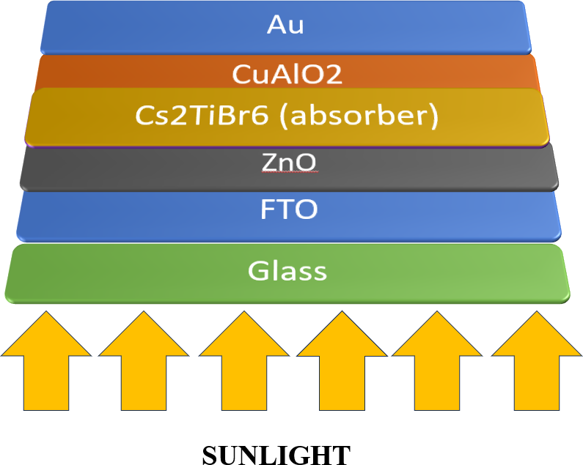

Fig.3 (a): Device architecture of n-i-p perovskite solar cell.

Scope and Significance

Research and Development

Material Innovation:
Globally, there is extensive research into improving the composition of perovskite materials to boost efficiency, stability, and environmental friendliness. Research institutions and companies are exploring mixed-cation, mixed-halide, and lead-free perovskite formulations, with a focus on overcoming issues such as toxicity and degradation.

Device Architecture:
PSCs are continually evolving in structure, with a focus on tandem cells (combining perovskite and silicon layers) to surpass the efficiency limits of traditional single-junction solar cells.

Stability and Durability:
A significant part of research is dedicated to enhancing the long-term stability of perovskite cells, which degrade when exposed to moisture, oxygen, and heat. Global initiatives aim to create encapsulation techniques and interface engineering solutions that can make PSCs viable for practical, long-term use.

Commercialization Potential

Cost Efficiency:
One of the main attractions of PSCs is the potential for low-cost production using solution-based methods. Unlike silicon solar cells, perovskites can be manufactured with less energy input and on flexible substrates, which could reduce the overall cost per watt significantly.

Manufacturing Scaling:
Countries around the world are exploring ways to transition from lab-scale to industrial-scale production. The scalability of perovskites is being tested for large-scale manufacturing, with an emphasis on roll-to-roll printing, spray coating, and other scalable fabrication methods.

Global Market Potential:
With their low cost and high efficiency, perovskite solar cells have the potential to meet the growing global energy demand, particularly in developing countries where low-cost energy solutions are crucial.

Environmental and Health Considerations

Toxicity Concerns:
The presence of lead in many perovskite materials poses health and environmental risks, especially if the cells are deployed on a large scale. There is global research to develop lead-free perovskite alternatives or implement safe recycling protocols for lead-based cells to mitigate environmental impacts.

Sustainability:
PSCs have a shorter lifespan than silicon cells, which has implications for waste management. Developing sustainable disposal, recycling strategies, and long-lasting

perovskite materials is critical to their acceptance as an environmentally responsible energy solution.

Large-Scale Deployment and Applications

Emerging Applications:
Given their flexibility, perovskites can be applied on surfaces unsuitable for traditional silicon cells, such as building-integrated photovoltaics (BIPV), wearable devices, and portable solar applications. Global initiatives are exploring PSCs for space applications due to their high power-to-weight ratio.

Global Collaboration and Policy Support

Collaborative Research Efforts:
Countries and organizations are actively collaborating on PSC development through research consortia, such as the European Union's Horizon 2020 projects, the United States’ National Renewable Energy Laboratory (NREL), and China’s rapidly growing perovskite research base.

Policy and Incentives:
Governments are beginning to support PSC development with funding, incentives, and policies focused on green technology. Such policies are intended to stimulate private investment and accelerate the deployment of PSCs as a renewable energy source.

Project Outline
The project outline provides a structured roadmap for the development, analysis, and optimization of perovskite solar cells. It outlines the key components of the project report, detailing the flow of information and the major topics covered in each section. Below is a detailed breakdown of the project outline for solar cell development:

Introduction
The introduction section sets the foundation for the entire project, offering background information on solar energy and perovskite solar cells (PSCs). It introduces the problem of energy sustainability and the growing importance of renewable energy sources, with a focus on PSCs. This section outlines the objectives of the project, which include enhancing the power conversion efficiency (PCE) of PSCs, exploring alternative materials such as tin-based perovskites, and optimizing various device parameters. The significance of this project in contributing to eco-friendly energy solutions is also discussed, followed by an overview of the subsequent sections.

Literature Review
This section provides a comprehensive review of existing research related to solar cell technology, particularly perovskite-based solar cells. It covers the evolution of PSCs, their material properties, efficiency improvements, challenges related to stability, toxicity (especially with lead), and the development of lead-free alternatives.

Methodology
The methodology section describes the approach taken to optimize and model perovskite solar cells. This includes the use of SCAPS-1D simulation software for modeling different perovskite materials, such as CH₃NH₃Pb(I₁₋ₓClₓ)₃, CH₃NH₃SnBr₃, and Cs₂TiBr₆ (Cesium titanium bromide). It outlines the process of material selection, simulation setup, and the optimization of critical parameters like absorber thickness, temperature, and the choice of ETLs and HTLs.

Results and Discussion
In this section, the results of the simulations are presented and analyzed. This includes the efficiency metrics (PCE, open-circuit voltage, current density, and fill factor) achieved through different configurations of perovskite materials and layer combinations.

References
The references section lists all the academic papers, books, articles, and other sources referenced throughout the project. It provides a comprehensive list of research materials related to perovskite solar cells, materials science, and solar energy technology.

Literature Review

Evolution and Development of Perovskite Solar Cells
Historical Context: Perovskite materials were first recognized for their photovoltaic properties in the early 2000s. Their application in solar cells began to gain attention when the first perovskite solar cell (PSC) was fabricated in 2009. Since then, the efficiency of PSCs has surged from just a few percent to over 25% in less than a decade. This rapid growth is largely due to advancements in material science, fabrication techniques, and device engineering.
Current Efficiency Benchmarks: Today, perovskite solar cells have achieved efficiencies comparable to traditional silicon-based solar cells, often exceeding 20% in laboratory settings. However, one of their major advantages is their significantly lower production cost. This is because PSCs can be fabricated using solution-based processes such as spin coating or inkjet printing, which are cheaper and more versatile than the high-temperature processes required for silicon cells. As a result, PSCs are now considered one of the most promising candidates for next-generation photovoltaic technologies.

Challenges in Perovskite Solar Cell Development
Stability and Toxicity: Despite their impressive efficiency, PSCs face significant challenges, particularly related to stability and toxicity. Perovskite materials are highly sensitive to moisture and ultraviolet (UV) degradation, which leads to a decline in performance over time. Additionally, many perovskite solar cells use lead-based materials, which pose environmental and health risks due to their toxicity. These issues have slowed the large-scale adoption of PSCs and raised concerns about their long-term viability in real-world applications.
Lead-Free Perovskite Alternatives: To address the toxicity concerns associated with lead-based perovskites, researchers have been exploring lead-free alternatives. Tin-based perovskites, such as CH₃NH₃SnI₃, have shown promise as viable replacements due to their similar electronic properties to lead. However, tin-based PSCs face their own set of challenges, primarily lower efficiencies and increased instability due to the oxidation of Sn²⁺ to Sn⁴⁺ in the presence of halide ions like bromine (Br). Research is ongoing to optimize these materials and improve their stability and performance to make lead-free PSCs commercially viable. To address the environmental and toxicity concerns associated with lead-based perovskites, Cs₂TiBr₆ (Cesium titanium bromide) is emerging as a promising lead-free alternative. This material presents a significant opportunity for sustainable solar energy solutions due to its non-toxic nature. Unlike traditional lead-based perovskites, Cs₂TiBr₆ does not contain toxic elements like lead (Pb), making it a safer choice for both the environment and human health.

Optimization of Charge Transport Layers (CTLs)
Role of ETLs and HTLs: Efficient charge transport layers (CTLs) are essential for enhancing the performance of PSCs. The electron transport layer (ETL) and hole transport

layer (HTL) are responsible for collecting and transporting the generated charge carriers—electrons and holes—toward the respective electrodes. The quality of these layers directly affects the open-circuit voltage (Voc), short-circuit current density (Jsc), and fill factor (FF) of the solar cell, all of which contribute to the overall power conversion efficiency (PCE). High efficiency is achieved when the ETL and HTL materials promote fast charge extraction while minimizing recombination losses, which would otherwise reduce the amount of current generated by the solar cell.
HTL and ETL Material Innovations: Significant progress has been made in optimizing the materials used for ETLs and HTLs. For ETLs, materials like TiO₂, ZnO, and SnO₂ are commonly used due to their favorable electronic properties, such as high electron mobility and excellent stability. These materials help facilitate the efficient transfer of electrons from the perovskite layer to the electrode. On the other hand, HTLs such as PEDOT, Spiro-MeOTAD, and CuO are employed to efficiently transport holes. These materials play a crucial role in enhancing the overall efficiency of the device by reducing charge recombination and increasing charge mobility. Recent studies have focused on improving the performance of these materials through doping, compositional tuning, and interface engineering to optimize the electronic properties and achieve better device performance. These advancements have had a direct impact on improving the PCE, Voc, and Jsc of PSCs, bringing them closer to commercial realization.

Materials and Methodology

Data Collection and Preprocessing
The entire study has been conducted using SCAPS-1D simulation software to model and analyze the performance of three different highest PCE (Power Conversion Efficiency) perovskite solar cell (PSC) structures:

FTO/ZnO/CH₃NH₃Pb(I₁₋ₓClₓ)₃/PEDOT/Au

This structure represents a lead-based perovskite solar cell with methylammonium lead halide (CH₃NH₃Pb(I₁₋ₓClₓ)₃) as the absorber layer. Zinc oxide (ZnO) serves as the electron transport layer (ETL), PEDOT is used as the hole transport layer (HTL), and gold (Au) is used as the top electrode. This configuration is widely studied for its high efficiency and has served as a baseline for many PSC developments.

FTO/ZnO/CH₃NH₃SnBr₃/Spiro-OMeTAD/Au

The second structure represents a lead-free perovskite solar cell using methylammonium tin bromide (CH₃NH₃SnBr₃) as the absorber layer. Zinc oxide (ZnO) continues to serve as the electron transport layer (ETL), while Spiro-OMeTAD is used as the hole transport layer (HTL). Gold (Au) is again used as the top electrode. This configuration aims to address environmental and toxicity concerns associated with lead-based perovskites.

FTO/ZnO (ETL)/Cs₂TiBr₆/CuAlO₂ (HTL)/Au

The third structure represents a lead-free perovskite solar cell using Cs₂TiBr₆ (Cesium titanium bromide) as the absorber layer. Zinc oxide (ZnO) serves as the electron transport layer (ETL), while CuAlO₂ is used as the hole transport layer (HTL). Gold (Au) serves as the top electrode. This configuration aims to address environmental concerns by replacing lead with a non-toxic material while maintaining efficient solar energy conversion.

Theoretical Concept
The simulations are conducted to investigate various parameters, including material properties (bandgap, electron/hole mobility, thickness), temperature dependence, and other performance metrics (like power conversion efficiency, open-circuit voltage, short-circuit current density, and fill factor) to optimise both the lead-based and lead-free perovskite solar cell designs.
Numerical simulation of perovskite solar cells is carried out using the SCAPS-1D simulation tool based on Poisson's equation, charge density equation, and drift-diffusion current equation. The Poisson's equation is defined as:

∇2 φ(𝑥) = − ρ(𝑥)/ε
Here ∇²φ(x): Laplacian of the electrostatic potential φ(x) ρ(x): Charge density at a point x
ε: Permittivity of the material
The charge density can be expressed as
ρ(𝑥) = 𝑞(𝑝(𝑥) – 𝑛(𝑥) + ( 𝑁𝐷 +) – (𝑁𝐴 −)
Here q: Elementary charge, p(x): Hole concentration, n(x): electron concentration,
ND⁺: Ionized donor concentration, N_{A}-: Ionized acceptor concentration.
The current density of electrons (Jn) and holes (Jp) is composed of both drift and diffusion components:
𝐽𝑛(𝑥) = 𝑞μ𝑛 𝑛(𝑥)ε(𝑥) + 𝑞𝐷𝑛 𝜕𝑛(𝑥)/𝜕𝑥
𝑝(𝑥) = 𝑞μ𝑝 𝑝(𝑥)ε(𝑥) − 𝑞𝐷𝑝 𝜕𝑝(𝑥)/𝜕𝑥
Here q as electric charge μn, μp: Electron and hole mobilities, respectively, n(x), p(x): Electron and hole concentrations, respectively,
ε(x): Electric field,
Dn, Dp: Electron and hole diffusion coefficients, respectively

Solar Cell Performance Evaluation
The performance of perovskite solar cells is evaluated based on several key parameters:
- Open-Circuit Voltage (Voc): This is the voltage of the solar cell when no current flows, which reflects the ability of the device to maintain a potential difference.
- Short-Circuit Current Density (Jsc): The current density when the voltage is zero, reflecting the amount of current the solar cell can generate under light conditions.
- Fill Factor (FF): The fill factor is a measure of the quality of the solar cell’s current-voltage (I-V) curve, quantifying how closely the actual power output approaches the theoretical maximum:
𝐹𝐹 = ((𝑃𝑚𝑎𝑥))/((𝑉𝑜𝑐 * 𝐼𝑠𝑐))

Power Conversion Efficiency (PCE): The ratio of the maximum output power to the input power.
η = ((𝐽𝑠𝑐 * 𝑉𝑜𝑐 * 𝐹𝐹))/𝑃𝑖𝑛
P_{in}: Input power intensity ,
P_{max}: Maximum power output of the solar cell

Device Structure and Layer Composition (CH₃NH₃Pb(I₁₋ₓClₓ)₃)
The device structure used in this study follows the conventional perovskite solar cell (PSC) architecture of FTO/ETL/CH₃NH₃Pb(I₁₋ₓClₓ)₃/HTL/Au. Each layer in this configuration plays a crucial role in the overall performance of the solar cell:
    - FTO (Fluorine-doped Tin Oxide): The FTO layer serves as the transparent conductive oxide (TCO) at the bottom of the solar cell. It is responsible for providing electrical conductivity and allowing light to pass through to the perovskite layer. The transparency of FTO ensures that most of the incident light can reach the absorber layer.
    - ETL (Electron Transport Layer): The ETL, commonly made from materials like TiO₂, ZnO, or SnO₂, is responsible for collecting and transporting the electrons generated by the perovskite layer upon absorption of light. It also acts as a barrier to prevent the flow of holes into the electrode, thereby reducing recombination losses. The ETL needs to have a high electron mobility and a suitable band alignment to efficiently transport electrons to the electrode.
    - Perovskite Layer (CH₃NH₃Pb(I₁₋ₓClₓ)₃): The perovskite absorber layer is the heart of the solar cell, where light is absorbed and converted into electron-hole pairs. The material used in this study, methylammonium lead halide (CH₃NH₃Pb(I₁₋ₓClₓ)₃), has excellent optical absorption and charge carrier properties, making it a highly efficient absorber for photovoltaic applications. The perovskite layer’s bandgap is crucial for light absorption efficiency and determines how much of the solar spectrum the device can capture.
    - HTL (Hole Transport Layer): The HTL, such as Spiro-OMeTAD or PEDOT, is responsible for transporting the holes to the top electrode. It also helps in minimizing recombination by blocking electrons from reaching the top electrode. A well-chosen HTL material ensures effective hole mobility, contributing to higher efficiency.
    - Au (Gold Electrode): The gold layer is used as the back contact and plays an important role in collecting holes from the HTL and facilitating current extraction. Its high conductivity is essential for minimizing losses during charge collection

Table 1: Input parameters of the absorber layer, ETL and TCO.

Parameters | TCO[15] | TiO₂[15,16] | ZnO[17] | SnO₂[18,19] | Zn(O,S)[ 20] | PCBM[21] | MAPbI(I₁₋ₓClₓ)₃[15]
Thickness (nm) | 400 | 70 | 70 | 70 | 70 | 70 | 450
Bandgap, Eg (eV) | 3.5 | 3.2 | 3.3 | 3.5 | 2.83 | 2.0 | 1.55
Electron affinity χ (eV) | 4 | 4.26 | 4.1 | 4 | 3.6 | 3.9 | 3.93
Relative dielectric permittivity, Єr | 9 | 10 | 9 | 9 | 9 | 4 | 6.5
CB effective density of states Nc(cm⁻³) | 2.2 ×10¹⁸ | 2.2 ×10¹⁸ | 4.0  ×10¹⁸ | 2.2 ×10¹⁸ | 2.2 ×10¹⁸ | 2.5 ×10¹⁹ | 2.2 ×10¹⁷
VB effective density of states Nv(cm⁻³) | 1.8 ×10¹⁹ | 1.8 ×10¹⁹ | 1.8  ×10¹⁹ | 1.8 ×10¹⁹ | 1.9 ×10¹⁹ | 2.5 ×10¹⁹ | 1.8 ×10¹⁹
Electron mobility μn(cm²V⁻¹S⁻¹) | 20 | 20 | 100 | 20 | 100 | 0.2 | 20
Hole mobility μh(cm²V⁻¹S⁻¹) | 10 | 10 | 25 | 10 | 15 | 0.2 | 20
Shallow uniform donor density ND (cm⁻³) | 12.0  ×10¹⁹ | 6.0 ×10¹⁹ | 1.0  ×10¹⁸ | 1.0 ×10¹⁷ | 1.0 ×10¹⁹ | 5.0 ×10¹⁷ | -
Shallow uniform acceptor density NA (cm⁻³) | - | - | - | - | - | - | -
Total defect density Nt (cm⁻³) | - | - | - | - | - | - | 1.0 ×10¹⁴

Table 2 Input parameters of the HTLs.

Parameters | Spiro-MeOTAD [17] | PEDOT:PSS[15,21] | CuO[15] | Cu₂O[15,20] | CuSCN[15,19  ] | CuSbS₂[19]
Thickness (nm) | 100 | 100 | 100 | 100 | 100 | 100
Bandgap, Eg (eV) | 3.0 | 1.8 | 1.5 | 2.1 | 3.6 | 1.58
Electron affinity χ (eV) | 2.45 | 3.5 | 4.07 | 3.2 | 1.7 | 4.2
Relative dielectric permittivity, Єr | 3 | 10 | 18.1 | 7.11 | 10 | 14.6
CB effective density of states Nc(cm⁻³) | 2.2 ×10¹⁸ |  | 2.2 ×10¹⁹ | 2.2 ×10¹⁸ | 2.5 ×10¹⁸ | 2.0 ×10¹⁸
VB effective density of states Nv(cm⁻³) |  | 2.2 ×10¹⁸ | 5.5 ×10²⁰ | 1.9 ×1019 | 1.8 ×1019 | 1.0 ×10¹⁹
Electron mobility μn(cm²V⁻¹S⁻¹) |  |  | 100 | 200 | 100 | 49
Hole mobility  μh(cm²V⁻¹S⁻¹) | 1.9 ×10¹⁹ | 1.8 ×10¹⁹ | 0.1 | 8600 | 25 | 49
Shallow uniform donor density ND (cm⁻³) | 50 | 100 | - | - | - | -
Shallow uniform acceptor density NA (cm⁻³) | 50 | 4 | 1.0 ×10¹⁵ | 1.0 ×10¹⁸ | 1.0 ×10¹⁸ | 1.0 ×10¹⁸

Table 3 Input parameters of interface defect and absorber defect.

Parameters and units | CH₃NH₃Pb(I₁₋ₓClₓ)₃ | ETL/CH₃NH₃Pb(I₁₋ₓClₓ)₃ interface | CH₃NH₃Pb(I₁₋ₓClₓ)₃/HTL interface
Defect type | Neutral | Acceptor | Acceptor
Capture cross section for electrons and holes (cm²) | 2.0 ×10⁻¹⁴,2.0 ×10⁻¹⁴ | 1.0 ×10⁻¹⁷,1.0 ×10⁻¹⁸ | 1.0 ×10⁻¹⁸,1.0 ×10⁻¹⁹
Energetic distribution | Gaussian | Single | Single
Energy level with respect to EV (above EV, eV) | 0.6 | 0.6 | 0.6
Characteristic energy (eV) | 0.1 | - | -
Total density (cm⁻³) | 1.0 ×10¹³ | 1.0 ×10¹⁰-1.0 ×10¹² | 1.0 ×10¹⁰-1.0 ×10¹²

Device Structure and Layer Composition (CH₃NH₃SnBr₃)
In this study, a lead-free perovskite solar cell (PSC) with the structure FTO/ZnO/CH₃NH₃SnBr₃/SpiroOMeTAD/Au is used. The detailed description of each layer is provided below:

FTO (Fluorine-doped Tin Oxide):
The FTO layer serves as the bottom transparent conductive oxide (TCO). It allows light to pass through to the perovskite absorber layer while simultaneously providing electrical conductivity for current collection. The high transparency and conductivity of FTO make it an ideal choice for the bottom electrode in the PSC structure.

ETL (Electron Transport Layer) - ZnO:
The ZnO layer acts as the electron transport layer (ETL) in this device. The primary function of the ETL is to collect and transport electrons generated in the perovskite absorber layer to the electrode. ZnO is chosen because of its high electron mobility, excellent stability, and appropriate energy band alignment with the perovskite layer, ensuring efficient electron flow while blocking holes from reaching the bottom electrode.

Perovskite Absorber Layer (CH₃NH₃SnBr₃):
The CH₃NH₃SnBr₃ layer is the lead-free perovskite material used as the absorber in this PSC. This tin-based perovskite material absorbs light from the solar spectrum and generates electron-hole pairs. The perovskite material’s low bandgap (around 1.3–1.5 eV) allows it to efficiently absorb a broad range of light wavelengths. However, tin-based perovskites face challenges with stability and efficiency, especially due to the tendency of Sn²⁺ ions to oxidise. Despite these challenges, this material is a promising lead-free alternative due to its environmental and health benefits.

HTL (Hole Transport Layer) - SpiroOMeTAD:
The SpiroOMeTAD layer serves as the hole transport layer (HTL) in this device. Its primary function is to transport the holes from the perovskite absorber layer to the top electrode (Au). SpiroOMeTAD is commonly used in PSCs due to its excellent hole mobility and high stability, which make it an effective material for hole conduction while preventing recombination. The material’s energy band alignment with the perovskite absorber helps minimise the potential barriers for hole extraction.

Au (Gold Electrode):
The Au layer serves as the top contact electrode. It collects the holes transported through the HTL and facilitates current extraction. Gold is chosen due to its high conductivity and excellent contact properties with the HTL material, ensuring efficient hole collection and minimising contact resistance.
Table 1: Input parameters of the absorber layer, ETL and TCO.

Parameters | TCO[15] | TiO₂[15,16] | ZnO[17] | Zn(O,S)[16] | CH₃NH₃SnBr₃
Thickness (nm) | 400 | 70 | 70 | 70 | 500

Bandgap, Eg (eV) | 3.5 | 3.2 | 3.3 | 2.83 | 1.3
Electron affinity χ (eV) | 4 | 4.26 | 4.1 | 3.6 | 4.17
Relative dielectric permittivity, Єr | 9 | 10 | 9 | 9 | 10
CB effective density of states Nc(cm⁻³) | 2.2 ×10¹⁸ | 2.2 ×10¹⁸ | 4.0 ×10¹⁸ | 2.2 ×10¹⁸ | 2.2 ×10¹⁸
VB effective density of states Nv(cm⁻³) | 1.8 ×10¹⁹ | 1.8 ×10¹⁹ | 1.8 ×10¹⁹ | 1.9 ×10¹⁹ | 1.8 ×10¹⁸
Electron mobility μn(cm²V⁻¹S⁻¹) | 20 | 20 | 100 | 100 | 1.6
Hole mobility μh(cm²V⁻¹S⁻¹) | 10 | 10 | 25 | 15 | 1.6
Shallow uniform donor density ND (cm⁻³) | 2.0 ×10¹⁹ | 6.0 ×10¹⁹ | 1.0 ×10¹⁸ | 1.0 ×10¹⁹ | 1× 10¹³
Shallow uniform acceptor density NA (cm⁻³) | - | - | - | - | 1× 10¹³
Total defect  density Nt (cm⁻³) | - | - | - | - | 1.0 ×10¹⁴

Table 2 Input parameters of the HTLs.

Parameters | Spiro-MeOTAD[17] | PEDOT:PSS[15,21] | CuO[15] | Cu₂O[15]
Thickness (nm) | 100 | 100 | 100 | 100
Bandgap, Eg (eV) | 3.0 | 1.8 | 1.5 | 2.1
Electron affinity χ (eV) | 2.45 | 3.5 | 4.07 | 3.2
Relative dielectric permittivity, Єr | 3 | 10 | 18.1 | 7.11
CB effective density of states Nc(cm⁻³) | 2.2 ×10¹⁸ | 2.2 ×10¹⁸ | 2.2 ×10¹⁹ | 2.2 ×10¹⁸
VB effective density of states Nv(cm⁻³) | 1.9× 10¹⁹ | 1.8 ×10¹⁹ | 5.5 ×10²⁰ | 1.9 ×10¹⁹
Electron mobility μn(cm²V⁻¹S⁻¹) | 50 | 100 | 100 | 200
Hole mobility μh(cm²V⁻¹S⁻¹) | 50 | 4 | 0.1 | 8600
Shallow uniform donor density ND (cm⁻³) | - | - | - | -
Shallow uniform acceptor density NA (cm⁻³) | 1 ×10¹⁸ | 2× 10¹⁹ | 1.8 ×10¹⁸ | 1.0 ×10¹⁸

Table 3 Input parameters of interface defect and absorber defect.

Parameters and units | CH₃NH₃SnBr₃ | ETL/CH₃NH₃SnBr₃ interface | CH₃NH₃SnBr₃ /HTL interface
Defect type | Neutral | Acceptor | Acceptor

Capture cross section for electrons and holes (cm²) | 2.0 ×10⁻¹⁴,2.0 ×10⁻¹⁴ | 1.0 ×10⁻¹⁷,1.0 ×10⁻¹⁸ | 1.0 ×10⁻¹⁸,1.0 ×10⁻¹⁹
Energetic distribution | Gaussian | Single | Single
Energy level with respect to EV (above EV, eV) | 0.6 | 0.6 | 0.6
Characteristic energy (eV) | 0.1 | - | -
Total density (cm⁻³) | 1.0 ×10¹³ | 1.0 ×10¹⁰-1.0 ×10¹² | 1.0 ×10¹⁰-1.0 ×10¹²

Device Structure and Layer Composition (Cs₂TiBr₆)

In this study, the FTO/ZnO/Cs₂TiBr₆/CuAlO₂/Au structure represents a lead-free perovskite solar cell (PSC) using Cs₂TiBr₆ (Cesium Titanium Bromide) as the absorber material. The detailed function of each layer in the device structure is as follows:

    - FTO (Fluorine-doped Tin Oxide): The FTO layer is the bottom transparent conductive oxide (TCO). It provides both optical transparency and electrical conductivity, allowing sunlight to pass through to the perovskite absorber layer while also enabling current collection. As a TCO, FTO plays a critical role in providing a conductive pathway for electrons that are generated by the photovoltaic effect.
    - ETL (Electron Transport Layer) - ZnO: The ZnO layer functions as the electron transport layer (ETL). The ETL is responsible for efficiently transporting the photo-generated electrons from the perovskite absorber layer to the bottom electrode (FTO) while blocking holes from reaching the bottom electrode. ZnO is an effective ETL because of its high electron mobility and favourable band alignment with Cs₂TiBr₆. Additionally, ZnO enhances the stability of the device and prevents recombination losses.
    - Perovskite Absorber Layer (Cs₂TiBr₆): The Cs₂TiBr₆ layer is the lead-free perovskite material used as the absorber in this device. This material is gaining attention due to its non-toxic nature and excellent optoelectronic properties. Cs₂TiBr₆ has a relatively wide bandgap (around 2.3 eV), which allows it to absorb a significant portion of the solar spectrum. Its lower toxicity compared to traditional lead-based perovskites (like MAPbI₃) makes it an environmentally friendly alternative. However,

like other lead-free materials, Cs₂TiBr₆ faces challenges related to achieving high efficiency and improving long-term stability under operational conditions.
    - HTL (Hole Transport Layer) - CuAlO₂: The CuAlO₂ layer functions as the hole transport layer (HTL) in this configuration. The HTL is responsible for transporting the holes from the perovskite layer to the top electrode (Au). CuAlO₂ is a copper-based material that has garnered attention for its high hole mobility and stability in perovskite solar cells. It also has a good energy band alignment with the perovskite layer, which facilitates efficient hole extraction while minimizing recombination.
    - Au (Gold Electrode): The Au layer serves as the top electrode, where the holes transported through the HTL are collected. Gold is a widely used material for the top contact due to its high conductivity, ease of deposition, and excellent stability. It ensures efficient hole extraction and provides a good electrical contact with the HTL.
TABLE 1 INPUT PARAMETERS OF ETLs

PARAMETERS | FTO | TiO2 | Zno | STO | IGZO | PCBM | ZnSe | CdS | WO3
Thickness ( nm ) | 500 | 30 | 30 | 30 | 30 | 30 | 30 | 30 | 30
BandGap , Eg(eV) | 3.2 | 3.2 | 3.3 | 3.2 | 3.05 | 2 | 2.81 | 2.4 | 2.92
Electrno affinity X (eV) | 4.4 | 3.9 | 4.1 | 4.0 | 4.16 | 3.9 | 4.09 | 4.18 | 4.590
Realtive Dielectric Permittivity | 9 | 9 | 9 | 8.7 | 10 | 4 | 8.6 | 10 | 5.76
CB , Effective density of states Nc ( cm-3 ) | 2.2X10¹⁸ | 1X10²¹ | 4X10¹⁸ | 1.7X10¹⁹ | 5X10¹⁸ | 1X10²¹ | 2.2X10¹⁸ | 2.2X10¹⁸ | 1.96X10¹⁹
VB , effective density of states Nv ( cm-3 ) | 1.8X10¹⁹ | 2X10²⁰ | 1X10¹⁹ | 2X10²⁰ | 5X10¹⁸ | 1.8X10¹⁹ | 1.8X10¹⁸ | 1.9X10¹⁹ | 1.96E¹⁹
Electron mobility ( cm2v-1s-1 ) | 90 | 20 | 100 | 5.3X10³ | 15 | 1E-2 | 4x10² | 100 | 1E+1
Hole mobility ( cm2v-1s-1) | 90 | 10 | 25 | 6.6X10² | 0.1 | 1E-2 | 1.1x10² | 25 | 1E+1
Shallow uniform donor density ND ( cm-3) | 7X10² | 1X10¹⁹ | 1X10¹⁸ | 2X10¹⁶ | 1X10¹⁸ | 1E+20 | 1x10¹⁸ | 1X10¹⁸ | 3.68E⁺¹⁹
Shallow acceptor density NA ( cm-3 ) | 0 | 0 | 0 | 0 | 0 | 0 | 0 | 0 | 0
Total defect density Nt( cm-3 ) | 1X10¹⁴ | 1X10¹⁴ | 1X10¹⁴ | 1X10¹⁴ | 1X10¹⁴ | 1X10¹⁴ | 1X10¹⁴ | 1X10¹⁴ | 1X10¹⁴

TABLE 2 INPUT PARAMETERS OF HTLs.

PARAMETERS | Cu20 | CuAlO2 | CuSbS2 | CuSCN | MoO3 | Spiro-OMeTAD | P3HT | PEDOT:PSS | Cs2TiBr6
Thickness ( nm ) | 30 | 30 | 30 | 30 | 30 | 30 | 30 | 30 | 900
BandGap , Eg(eV) | 2.17 | 3.46 | 1.58 | 3.2 | 3 | 3 | 1.85 | 2.2 | 1.6
Electron affinity X (eV) | 3.2 | 2.5 | 4.2 | 1.9 | 2.5 | 2.45 | 3.1 | 2.9 | 4.47
Relative Dielectric Permittivity | 7.1 | 60 | 14.6 | 10 | 12.5 | 3 | 3.4 | 3 | 10
CB , Effective density of states Nc  ( cm-3 ) | 2.02x10¹⁷ | 2.2X10¹⁸ | 2X10¹⁸ | 2.2X10¹⁹ | 2.2X10¹⁸ | 1X10¹⁹ | 1E+22 | 2.2E⁺¹⁵ | 1E19
VB , effective density of states Nv  ( cm-3 ) | 1.1x10¹⁹ | 1.8X10¹⁹ | 1X10⁻⁴ | 1.8X10¹⁹ | 1.8X10¹⁹ | 1X10¹⁹ | 1E+22 | 2.2E⁺¹⁷ | 1E19
Electron mobility ( cm2v-1s-1 ) | 200 | 2 | 49 | 1X10⁻⁴ | 100 | 2X10⁻⁴ | 1E-4 | 2X10⁻³ | 4.4
Hole mobility ( cm2v-1s-1) | 80 | 8.6 | 49 | 1X10⁻¹ | 25 | 2X10⁻⁴ | 1E-4 | 2X10⁻³ | 2.5
Shallow uniform donor density ND  ( cm-3) | 0 | 0 | 0 | 0 | 0 | 0 | 0 | 0 | 1E+19
Shallow acceptor density NA  ( cm-3 ) | 9 X 10²¹ | 3 X 10¹⁸ | 1.38X¹⁸ | 1X10¹⁵ | 1X10¹⁸ | 2X10¹⁸ | 3.17E¹³ | 1E+17 | 1E+19
Total defect density Nt  ( cm-3 ) | 1 X 10¹⁴ | 1X 10¹⁴ | 1 X 10¹⁴ | 1 X 10¹⁴ | 1 X 10¹⁴ | 1 X 10¹⁴ | 1 X 10¹⁴ | 1 X 10¹⁴ | 1 X 10¹⁴

Table 3 . input parameters of interface defect and absorber defect.

Parameters and units | Cs2TiBr6 | ETL/Cs2TiBr6 interface | Cs2TiBr6 / HTL interface
DEFECT TYPE | NEUTRAL | Acceptor | Acceptor

Capture cross section for electron and holes ( cm2 ) | 2.0X10⁻¹⁴ , 2X10⁻¹⁴ | 1.0X10⁻¹⁷ , 1X10⁻¹⁸ | 1.0X10⁻¹⁸ , 1X10⁻¹⁹
Energetic distribution | GAUSSIAN | SINGLE | SINGLE
Energy level with respect to EV ( above EV , eV ) | 0.6 | 0.6 | 0.6
Characteristics energy ( eV ) | 0.1 | - | -
Total Density ( cm-3 ) | 1.0 X 10¹³ | 1.0 X 10¹⁰ - 1.0 X 10¹² | 1.0 X 10¹⁰ - 1.0 X 10¹²

Results and Discussion

Impact of Material Properties on Solar Cell Performance
In this section, we will examine how variations in the material properties of both the absorber layer (perovskite material) and the transport layers (electron transport layer (ETL) and hole transport layer (HTL)) affect the overall performance of perovskite solar cells (PSCs). Key material properties like bandgap, charge carrier mobility, layer thickness, temperature dependence, and quantum efficiency are critical for optimizing PSC performance.

Bandgap
The bandgap of the absorber material (perovskite) determines the range of light that the material can absorb and convert into electrical energy. A larger bandgap absorbs high-energy (short-wavelength) photons but might not capture lower-energy (long-wavelength) photons efficiently. On the other hand, a smaller bandgap material can absorb a wider range of light, which can increase current density (Jsc), but if it's too small, it might lead to higher recombination losses and reduced open-circuit voltage (Voc). The bandgap needs to be carefully optimized to balance light absorption and charge transport efficiency.
- Lead-based perovskites (CH₃NH₃Pb(I₁₋ₓClₓ)₃): The bandgap is typically optimized around 1.55–1.6 eV, which is ideal for solar applications, as it allows absorption of visible light while maintaining a high voltage output.
- Lead-free alternatives (CH₃NH₃SnBr₃): The bandgap is usually around 1.3–1.5 eV, which provides a broader absorption spectrum. However, this could lead to lower efficiency and stability due to the material’s inherent properties.

Electron and Hole Mobility
The electron mobility (μn) and hole mobility (μp) in the ETL and HTL materials, respectively, affect how fast charge carriers (electrons and holes) can move through the solar cell. Higher mobility results in less resistance to charge flow, leading to more efficient charge collection at the electrodes, which in turn improves the short-circuit current density (Jsc).
- Electron mobility (μn): In the ETL (e.g., TiO₂, ZnO), the mobility of electrons is crucial for their efficient transfer from the perovskite layer to the electrode. Higher electron mobility results in lower recombination losses and higher Jsc.
- Hole mobility (μp): In the HTL (e.g., Spiro-MeOTAD, PEDOT), the hole mobility dictates how quickly holes can travel toward the anode. If the hole mobility is low, charge carrier recombination increases, resulting in lower efficiency.

Materials like ZnO and TiO₂ exhibit high electron mobility, which helps increase the overall current generated in the device. Spiro-MeOTAD, a commonly used HTL material, is known for its good hole mobility, thus enhancing efficiency.

Thickness
The thickness of each layer, particularly the absorber layer, plays a significant role in the efficiency of solar cells. A thicker absorber layer can absorb more light, increasing the short-circuit current density (Jsc). However, if the layer becomes too thick, it may lead to higher recombination losses, where electrons and holes combine before reaching the electrodes, thus reducing efficiency.
- A thin absorber layer might not capture enough light to generate sufficient current, reducing efficiency.
- Optimal thicknesses for each layer are typically determined through simulations and experiments to strike a balance between light absorption and minimizing recombination.
The thickness of the ETL and HTL layers also impacts carrier transport. Thicker layers can increase resistance, reducing the current and overall efficiency.

Temperature Dependence
The performance of PSCs is highly dependent on temperature. As the temperature rises, materials like perovskites often suffer from higher recombination rates, leading to a decrease in efficiency. Higher temperatures can also alter material properties, affecting carrier mobility, bandgap, and recombination losses.
- At higher temperatures, the Voc typically decreases because increased thermal energy allows charge carriers to overcome the potential barrier, reducing the voltage.
- The fill factor (FF) and power conversion efficiency (PCE) are often impacted by elevated temperatures, as higher thermal energy increases recombination and reduces the overall efficiency of the device.

Power Conversion Efficiency (PCE)
All the material properties—bandgap, mobility, and thickness—directly influence the PCE of the solar cell. The PCE is the ratio of the electrical power output to the total incident light power. Optimizing these parameters leads to the best possible performance in terms of efficiency. The higher the PCE, the more effective the device is at converting sunlight into usable electrical energy.

Quantum Efficiency (QE) in Perovskite Solar Cells
Quantum Efficiency (QE) is an important factor that determines how effectively incident light is converted into electrical current. It is divided into External Quantum Efficiency (EQE) and Internal Quantum Efficiency (IQE).

External Quantum Efficiency (EQE)
EQE refers to the ratio of charge carriers (electrons or holes) collected by the solar cell to the number of photons incident on the cell at a specific wavelength. It plays a significant role in determining how efficiently the cell converts light into electrical current.

Internal Quantum Efficiency (IQE)
IQE measures the number of charge carriers collected per absorbed photon, disregarding light that is reflected or transmitted.

Lead-Based Perovskite Solar Cell Performance Results
Lead-based perovskite solar cells, specifically those utilizing methylammonium lead halide (CH₃NH₃Pb(I₁₋ₓClₓ)₃) as the absorber layer, have demonstrated remarkable improvements in efficiency, making them a focal point of research for next-generation photovoltaic devices. The high power conversion efficiencies (PCEs) achieved by these solar cells, along with their relatively simple manufacturing processes, position them as a strong competitor to traditional silicon-based solar cells.

Simulation Setup and Parameters
In this study, the performance of lead-based perovskite solar cells was simulated using SCAPS-1D, which allows for the evaluation of various material configurations and performance parameters such as open-circuit voltage (Voc), short-circuit current density (Jsc), fill factor (FF), and power conversion efficiency (PCE). The chosen absorber layer, CH₃NH₃Pb(I₁₋ₓClₓ)₃, offers tunable properties based on the halide composition (I and Cl), allowing for fine-tuning of the material’s bandgap and absorption characteristics to optimize performance.

Performance Metrics

Power Conversion Efficiency (PCE):
The highest PCE achieved in this study was 24.98%, a significant result given the complexities of perovskite solar cell architecture. The increase in PCE is primarily attributed to the optimization of both the ETL and HTL, which reduced carrier recombination and improved charge collection efficiency.

Open-Circuit Voltage (Voc):
Voc is one of the key indicators of a solar cell's potential to convert light into electricity. For the lead-based perovskite solar cells, the highest Voc achieved was
1.12 V. This value aligns with the optimal bandgap for CH₃NH₃Pb(I₁₋ₓClₓ)₃, which allows for good light absorption while preventing excessive thermal losses.

Short-Circuit Current Density (Jsc):
Jsc, representing the maximum current density when the cell operates under short-circuit conditions, was found to be 32.43 mA/cm². This high Jsc indicates efficient light absorption and charge generation, which is influenced by the effective thickness and optical properties of the absorber layer.

Fill Factor (FF):
The fill factor, which measures the quality of the solar cell's I-V curve and represents how close the actual power output is to the theoretical maximum, was calculated to be 87.56%. This high FF suggests minimal recombination and efficient charge transport throughout the device.

Effect of ETL and HTL on Performance
The choice of electron transport layer (ETL) and hole transport layer (HTL) significantly influences the performance of perovskite solar cells. In the simulations, various materials were tested as ETLs and HTLs:
      - Electron Transport Layers (ETLs): Materials like TiO₂, ZnO, and SnO₂ were used for ETLs. The choice of ZnO as the ETL contributed to a good balance between electron mobility and effective charge collection at the cathode interface.
      - Hole Transport Layers (HTLs): Spiro-MeOTAD, PEDOT, and other HTLs were explored for their ability to transport holes efficiently while minimizing recombination. The use of Spiro-MeOTAD was particularly beneficial, offering high hole mobility and excellent interface stability, resulting in an improved PCE.

Lead-Free Perovskite Solar Cell Performance Results (CH₃NH₃SnBr₃)
Lead-free perovskite solar cells, particularly those utilizing CH₃NH₃SnBr₃ (methylammonium tin bromide) as the absorber material, offer an eco-friendly alternative to traditional lead-based perovskite solar cells. While lead-based perovskites have achieved impressive power conversion efficiencies (PCEs), lead-free alternatives aim to reduce environmental and toxicity concerns, though they face challenges in achieving similar performance levels. This section examines the performance of CH₃NH₃SnBr₃-based perovskite solar cells, compares key parameters (PCE, Voc, Jsc, FF) with lead-based cells, and explores the influence of different electron transport layers (ETLs) and hole transport layers (HTLs) on device efficiency.

Simulation Setup and Parameters
Using the SCAPS-1D simulation tool, lead-free perovskite solar cells with the structure FTO/ZnO/CH₃NH₃SnBr₃/SpiroOMeTAD/Au were modeled. Various ETL materials (ZnO, TiO₂) and HTL materials (Spiro-MeOTAD, PEDOT) were tested, and the impact of absorber thickness and temperature on the performance was analyzed. The key material properties for CH₃NH₃SnBr₃ and the chosen transport layers were carefully optimized to understand their effect on cell performance.

Performance Metrics

Power Conversion Efficiency (PCE):
The optimized lead-free perovskite solar cells achieved a maximum PCE of 27.26%, which is an impressive result compared to other lead-free perovskites. While lower than the highest efficiencies achieved with lead-based perovskites, this performance

indicates that lead-free materials can still provide competitive results under optimal conditions.

Open-Circuit Voltage (Voc):
The Voc of the lead-free perovskite solar cells was measured to be 1.019 V, which is slightly lower than the Voc of lead-based perovskite cells. This lower Voc can be attributed to the different electronic properties of tin-based perovskites, which have a wider bandgap compared to lead-based perovskites.

Short-Circuit Current Density (Jsc):
The Jsc achieved in the lead-free perovskite solar cells was 32.47 mA/cm². This high current density indicates that CH₃NH₃SnBr₃ can absorb significant amounts of sunlight and generate a high number of charge carriers, despite having a wider bandgap compared to lead-based perovskites.

Fill Factor (FF):
The fill factor for the lead-free perovskite solar cells was calculated to be 82.37%, which is a strong result, indicating good charge collection and minimal recombination losses.

Effect of ETL and HTL Materials on Performance
The choice of ETL and HTL materials plays a critical role in the overall performance of perovskite solar cells, including those using lead-free perovskite absorbers. In this study, several ETLs and HTLs were tested to evaluate their impact on the performance of CH₃NH₃SnBr₃-based devices.
      - Electron Transport Layers (ETLs): ZnO and TiO₂ were the primary ETL materials tested. ZnO performed well due to its good electron mobility and favorable band alignment with CH₃NH₃SnBr₃, which led to efficient electron extraction and high Jsc. TiO₂, commonly used in lead-based perovskite cells, also showed good performance but with slightly lower efficiency compared to ZnO.
      - Hole Transport Layers (HTLs): Spiro-MeOTAD was the most effective HTL material in enhancing the performance of lead-free perovskite solar cells. Its high hole mobility and stability helped improve both Voc and Jsc. PEDOT was also tested, but its performance was inferior to Spiro-MeOTAD, likely due to its lower hole mobility and potential issues with interface stability.

Comparison with Lead-Based Perovskite Solar Cells
Compared to the lead-based perovskite solar cells, the lead-free devices presented in this study show slightly lower efficiency metrics, particularly in terms of Voc and Jsc. However, the 27.26% PCE achieved in the lead-free perovskite cells is a significant step forward and demonstrates that lead-free alternatives have considerable potential for high-performance solar cells. Future research and improvements in material quality, charge transport layer optimization, and interface engineering may help to close the efficiency gap between lead-free and lead-based perovskite solar cells.

Lead-Free Perovskite Solar Cell Performance Results (Cs₂TiBr₆)

Lead-free perovskite solar cells, particularly those utilizing Cs₂TiBr₆ (cesium titanium bromide) as the absorber material, offer an eco-friendly alternative to traditional lead-based perovskite solar cells. Cs₂TiBr₆ has been shown to have a favorable bandgap and good charge transport properties, making it a promising candidate for next-generation solar cells.

Simulation Setup and Parameters
Using the SCAPS-1D simulation tool, lead-free perovskite solar cells with the structure FTO/ZnO/Cs₂TiBr₆/CuAlO₂/Au were modelled. Various ETL materials (e.g., TiO₂, ZnO) and HTL materials (Spiro-MeOTAD, PEDOT, CuAlO₂, etc.) were tested. The performance of Cs₂TiBr₆-based solar cells was optimized by analyzing the absorber thickness and temperature dependence.

Performance Metrics
    - Power Conversion Efficiency (PCE):
The highest PCE achieved with Cs₂TiBr₆ was 19.53%, a competitive result among lead-free materials.

Open-Circuit Voltage (Voc):
The Voc for Cs₂TiBr₆-based cells was 1.123 V, slightly lower than that of lead-based perovskite cells, but still promising.

Short-Circuit Current Density (Jsc):
Jsc was 23.54 mA/cm² for Cs₂TiBr₆, indicating efficient light absorption despite the material’s relatively wide bandgap.

Fill Factor (FF):
The FF achieved was 73.86%, showcasing good charge transport and minimal recombination losses.

Effect of Temperature and Absorber Thickness on Performance
In this section, the influence of two critical parameters—absorber thickness and operating temperature—on the performance of both lead-based and lead-free perovskite solar cells (PSCs) is analyzed. These parameters significantly impact the charge carrier dynamics, which include charge transport, recombination, and overall device efficiency.

Impact of Absorber Thickness on Performance
The absorber layer's thickness plays a pivotal role in the performance of perovskite solar cells. In this study, the absorber thickness was varied between 0.1 µm and 1.2 µm to evaluate its effect on the performance metrics, including power conversion efficiency (PCE), open-circuit voltage (Voc), short-circuit current density (Jsc), and fill factor (FF).

Thin Absorber Layer (0.1 µm to 0.5 µm)

- Optimal Absorber Thickness (0.7 µm to 1.0 µm)
.

- Thick Absorber Layer (1.1 µm to 1.2 µm)

Impact of Temperature on Performance
Temperature significantly influences the charge carrier dynamics and the overall performance of perovskite solar cells. The simulations were conducted within a temperature range of 300 K to 450 K to examine how temperature affects various performance metrics.
- Low Temperature (300 K to 350 K):
- Moderate Temperature (350 K to 400 K):
- High Temperature (400 K to 450 K):

Combined Effect of Absorber Thickness and Temperature
The combination of absorber thickness and temperature has a complex, nonlinear effect on the performance of perovskite solar cells. For instance:
- For thinner absorber layers at higher temperatures, the increase in Jsc may not compensate for the higher recombination rates, resulting in lower overall efficiency.
- For thicker absorber layers at lower temperatures, the reduced charge carrier mobility could hinder the performance despite the increased light absorption, leading to suboptimal results.
In contrast, optimal absorber thickness and temperature combinations (e.g., 0.7 -- 1.0 µm absorber thickness and 350–400 K temperature) result in higher PCEs due to enhanced carrier transport, reduced recombination, and efficient light absorption.

Graphs
Lead-Based PSC's Graph (CH₃NH₃Pb(I₁₋ₓClₓ)₃)

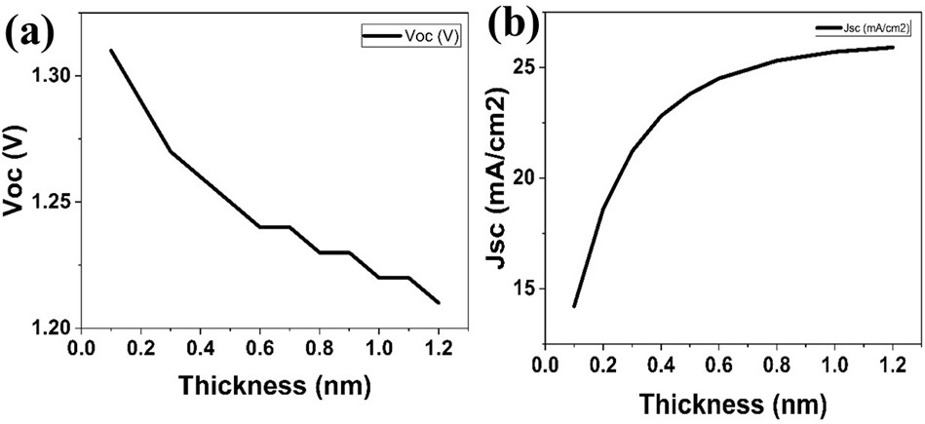

Fig. (a) V_{OC} variation with Lead free perovskite layer thickness

(b) J_{SC} variation with Lead free perovskite layer thickness.

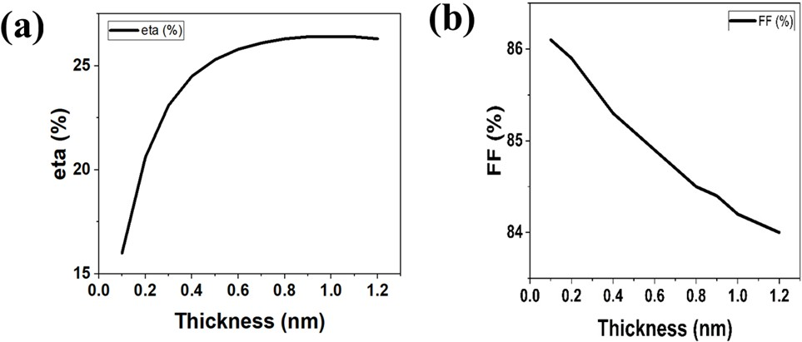

Fig. (a), ETA % variation with Lead free perovskite layer thickness

(b) Fill factor variation with Lead free perovskite layer thickness.

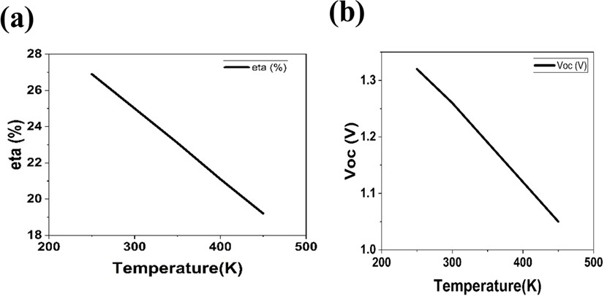

Fig. (a), eta% variation with temperature. (b) VOC variation with temperature

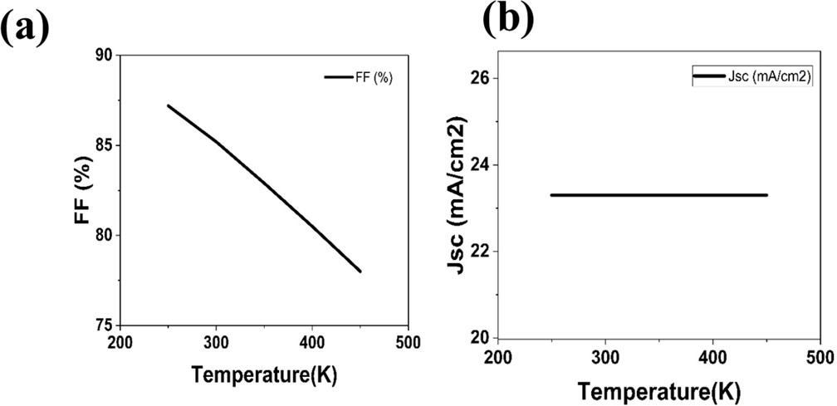

Fig. (a) FF variation with temperature. (b) JSc with temperature
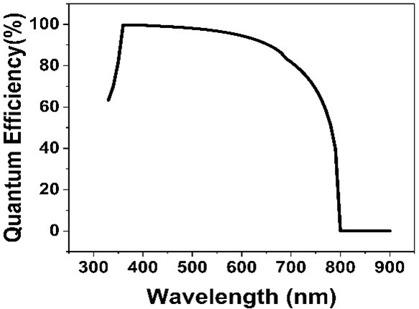

Fig. 5: Variation of Quantum efficiency as a function of wavelength

Lead-Free PSC's Graph (CH₃NH₃SnBr₃)
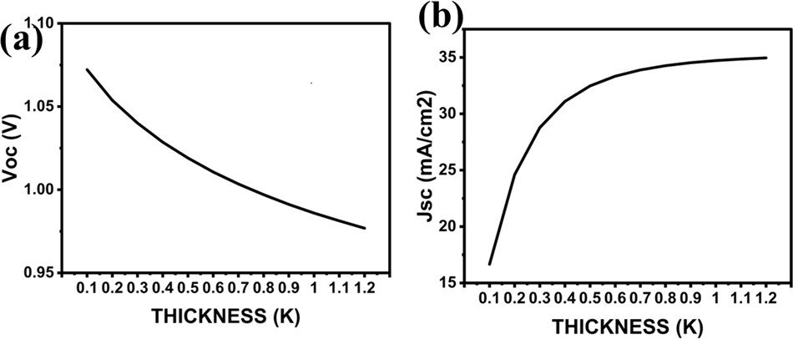
Fig. (a) V_{OC} variation with lead free perovskite layer thickness

(b) J_{SC} variation with lead free perovskite layer thickness.
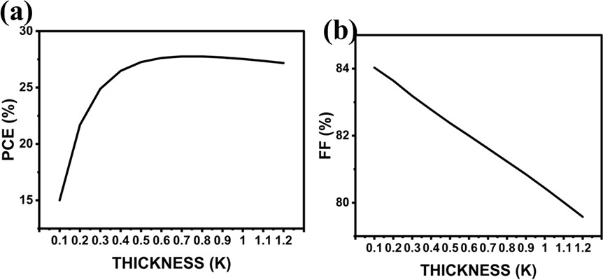
Fig. (a), ETA % variation with lead free perovskite layer thickness

(b) Fill factor variation with lead free perovskite layer thickness.

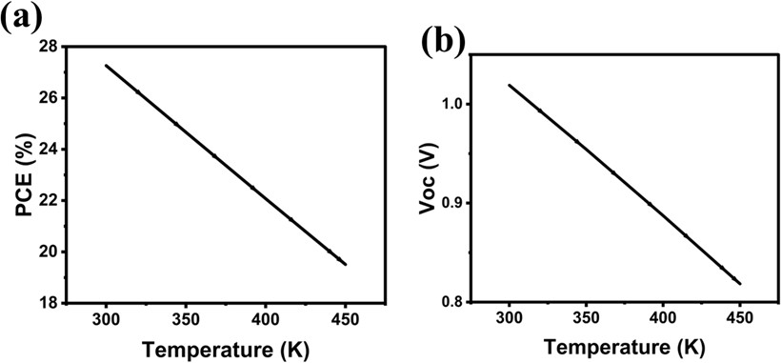
Fig. (a), eta% variation with temperature. (b) VOC variation with temperature
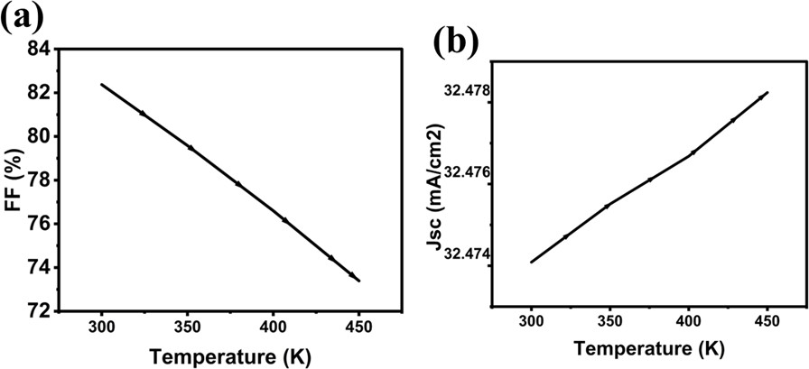
Fig. (a) FF variation with temperature. (b) JSc with temperature
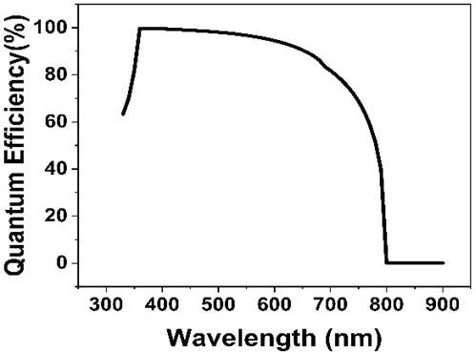
Fig. 5: Variation of Quantum efficiency as a function of wavelength.

Lead-Free PSC's Graph (Cs₂TiBr₆)

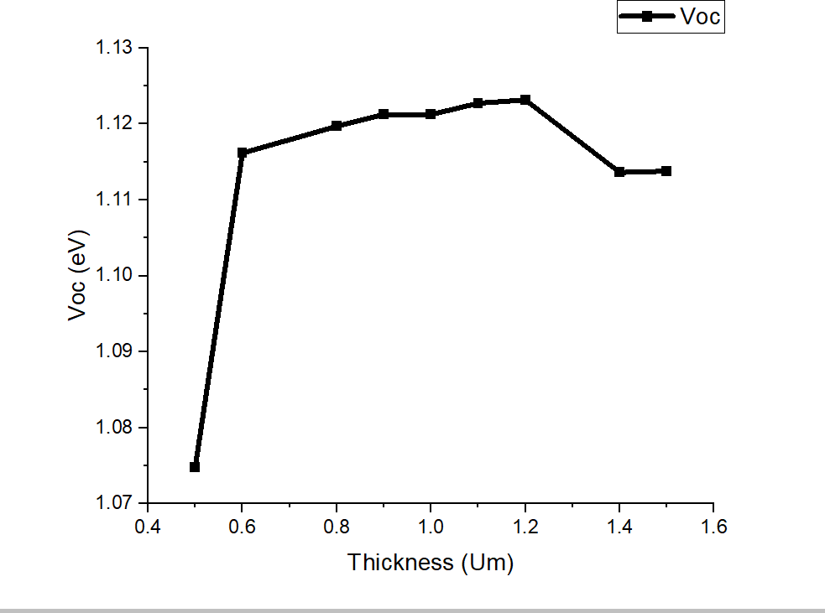
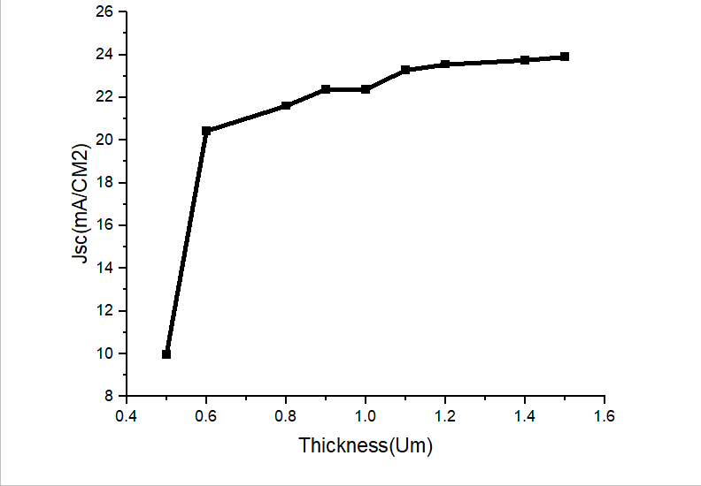
Fig. (a): VOC variation with Cs₂TiBr₆ perovskite layer thickness. Fig. (b): JSC variation with Cs₂TiBr₆ perovskite layer thickness.
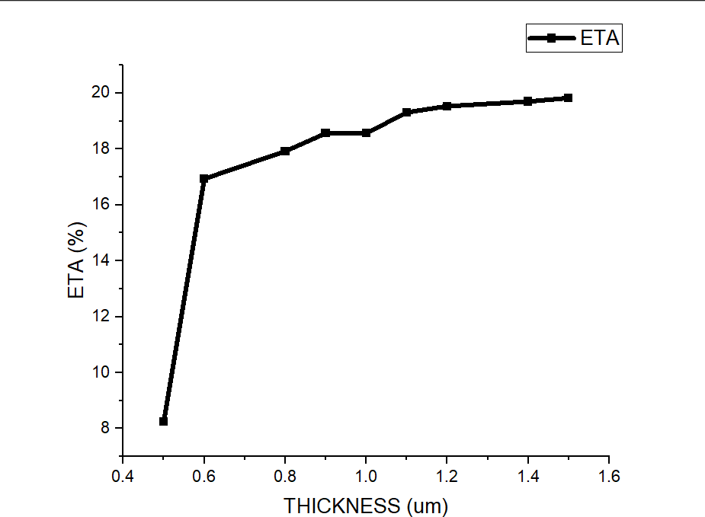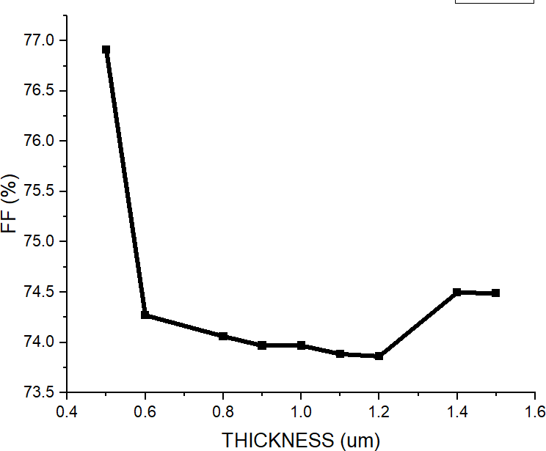

Fig. (a): ETA % variation with Cs₂TiBr₆ perovskite layer thickness. Fig. (b): Fill factor variation with Cs₂TiBr₆ perovskite layer thickness.
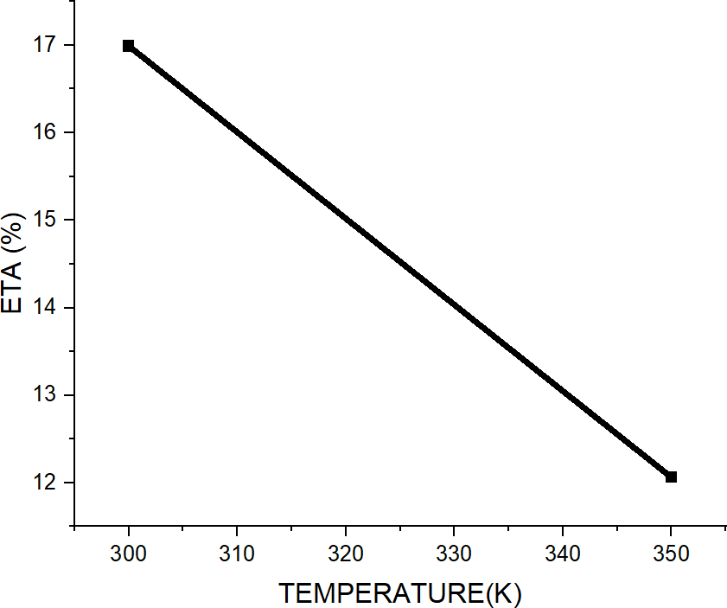
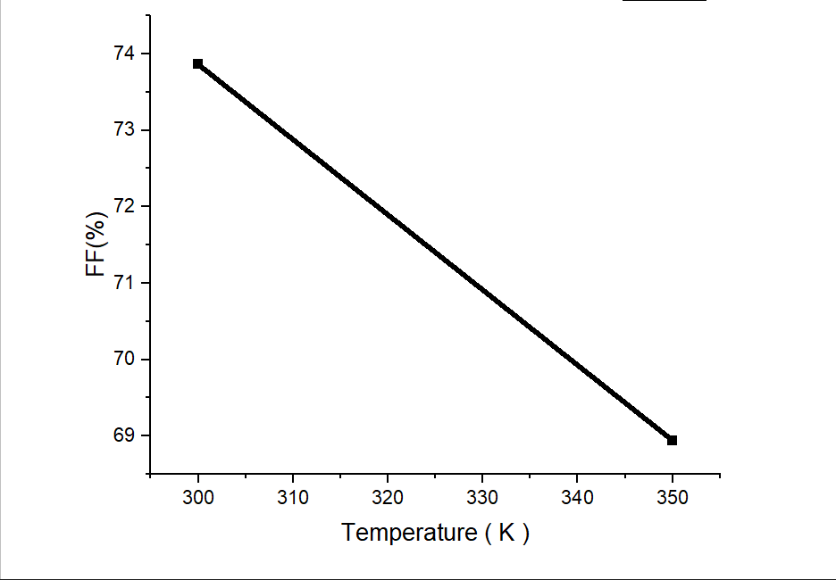

Fig. (a): ETA % variation with temperature. Fig. (b): VOC variation with temperature

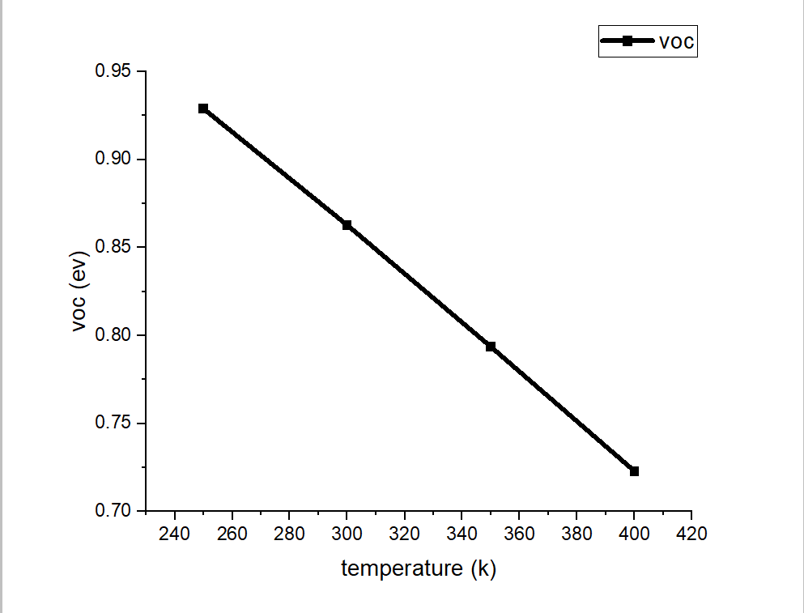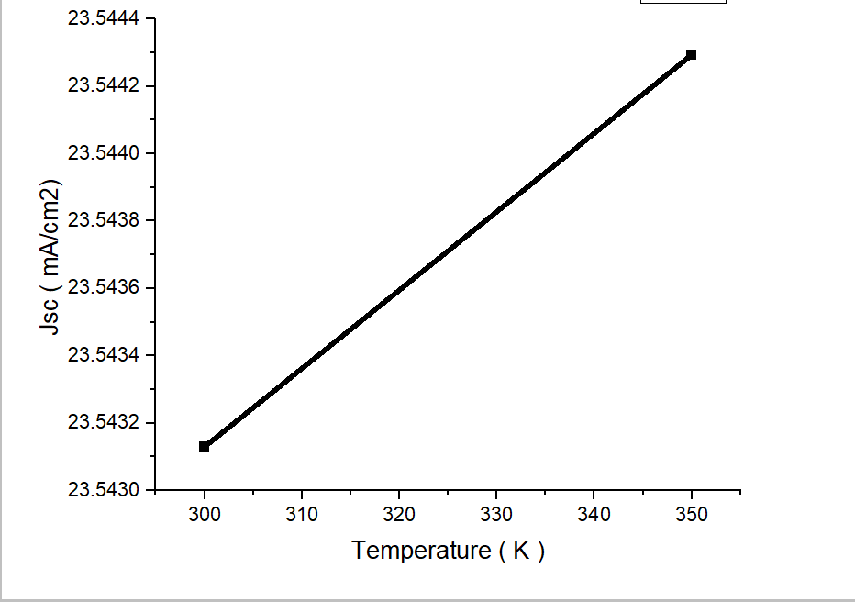

Fig. (a): FF variation with temperature. Fig. (b): JSC variation with temperature.

Jsc vs. Voc: Understanding the Relationship
The relationship between short-circuit current density (Jsc) and open-circuit voltage (Voc) in solar cells is central to understanding and optimizing device performance. Both Jsc and Voc are key performance metrics, but they are influenced by different factors and do not always show a simple, linear correlation. Here's a breakdown of how each parameter affects the other and their combined influence on the overall efficiency of solar cells:

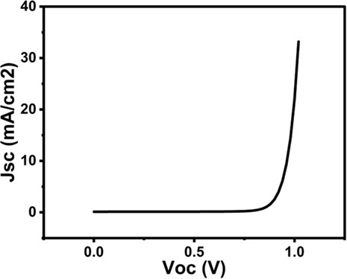
Fig.: Jsc Variation with Voc

SIMULATIONS RESULTS
- Lead-Free Perovskite Solar Cells – All 23 Results (CH₃NH₃SnBr₃)
The performance of CH₃NH₃SnBr₃ (methylammonium tin bromide) based lead-free perovskite solar cells has been simulated under 23 different conditions. The key performance metrics, including PCE, Voc, Jsc, and FF, were recorded Below are the simulation results

Structure of PSCs | Voc(V) | JSC  (mA/cm^2) | FF(%) | PCE(%)
FTO/ZnO/CH3NH3SnBr3/Spiro-MeOTA D/Au | 1.019 | 32.473836 | 82.37 | 27.26
FTO/PCBM/CH3NH3SnBr3/NiO/Au | 1.0167 | 32.505143 | 82.44 | 27.25
FTO/ZnO/CH3NH3SnBr3/NiO/Au | 1.0166 | 32.473743 | 82.47 | 27.22
FTO/SNO2/CH3NH3SnBr3/NiO/Au | 1.0162 | 32.473354 | 82.45 | 27.21
FTO/PCBM/CH3NH3SnBr3/Spiro-MeO TAD/Au | 1.0141 | 32.505007 | 82.3 | 27.13
FTO/TiO2/CH3NH3SnBr3/Spiro-MeOTA D/Au | 1.0144 | 32.474002 | 82.34 | 27.12
FTO/SNO2/CH3NH3SnBr3/Spiro-MeOT AD/Au | 1.0136 | 32.473537 | 82.31 | 27.1
FTO/TiO2/CH3NH3SnBr3/PEDOT:PSS/  Au | 1.0136 | 32.552992 | 81.73 | 26.97
FTO/PCBM/CH3NH3SnBr3/PEDOT:PS  S/Au | 1.0136 | 32.572029 | 81.7 | 26.97
FTO/ZnO/CH3NH3SnBr3/PEDOT:PSS/  Au | 1.0135 | 32.552702 | 81.72 | 26.96
FTO/SNO2/CH3NH3SnBr3/PEDOT:PSS  /Au | 1.0131 | 32.552442 | 81.71 | 26.95
FTO/PCBM/CH3NH3SnBr3/Cu2O/Au | 1.0152 | 32.523319 | 81.1 | 26.78

FTO/TiO2/CH3NH3SnBr3/Cu2O/Au | 1.0152 | 32.500159 | 81.13 | 26.77
FTO/ZnO/CH3NH3SnBr3/Cu2O/Au | 1.0151 | 32.499867 | 81.13 | 26.76
FTO/SNO2/CH3NH3SnBr3/Cu2O/Au | 1.0147 | 32.49968 | 81.1 | 26.75
FTO/PCBM/CH3NH3SnBr3/CuO/Au | 0.7814 | 32.785562 | 81.57 | 20.9
FTO/TiO2/CH3NH3SnBr3/CuO/Au | 0.7812 | 32.771479 | 81.56 | 20.88
FTO/ZnO/CH3NH3SnBr3/CuO/Au | 0.7812 | 32.771102 | 81.55 | 20.88
FTO/SNO2/CH3NH3SnBr3/CuO/Au | 0.7815 | 32.770419 | 81.51 | 20.88
FTO/ZN/CH3NH3SnBr3/NiO/Au | 1.0195 | 19.78755 | 36.28 | 7.32
FTO/ZN/CH3NH3SnBr3/Cu2O/Au | 1.018 | 19.745987 | 36.31 | 7.3
FTO/ZN/CH3NH3SnBr3/PEDOT:PSS/A  u | 1.0164 | 19.710055 | 36.33 | 7.28
FTO/ZN/CH3NH3SnBr3/CuO/Au | 0.7833 | 16.716404 | 39.7 | 5.2

Lead-Based Perovskite Solar Cells – All 30 Results (CH₃NH₃Pb(I₁₋ₓClₓ)₃)
The performance of CH₃NH₃Pb(I₁₋ₓClₓ)₃ (methylammonium lead halide) based lead-based perovskite solar cells was simulated under 30 different conditions. Below are the key performance results:

Structure of PSCs | Voc(V) | JSC  (mA/cm^2) | FF(%) | PCE(%)
FTO/TiO2/CH3NH3Pb(I1-xClx)3/  NiO/Au | 1.2534 | 23.054548 | 85.7 | 24.77

FTO/TiO2/CH3NH3Pb(I1-xClx)3/S  piro-MeOTAD/Au | 1.2523 | 23.056765 | 85.67 | 24.73
FTO/TiO2/CH3NH3Pb(I1-xClx)3/P EDOT:PSS/Au | 1.2513 | 23.321027 | 85.5 | 24.95
FTO/TiO2/CH3NH3Pb(I1-xClx)3/C  uO/Au | 0.9933 | 22.917347 | 82.1 | 18.69
FTO/TiO2/CH3NH3Pb(I1-xClx)3/C  u2O/Au | 1.2514 | 23.149117 | 84.41 | 24.45
FTO/TiO2/CH3NH3Pb(I1-xClx)3/C  uSb2/Au | 1.1735 | 23.531712 | 88.63 | 24.48
FTO/ZnO/CH3NH3Pb(I1-xClx)3/C  uSb2/Au | 1.1734 | 23.531607 | 88.35 | 24.4
FTO/ZnO/CH3NH3Pb(I1-xClx)3/C  u2O/Au | 1.2561 | 23.148805 | 83.66 | 24.33
FTO/ZnO/CH3NH3Pb(I1-xClx)3/C  uO/Au | 0.9861 | 22.921931 | 83.28 | 18.82
FTO/ZnO/CH3NH3Pb(I1-xClx)3/N  iO/Au | 1.2583 | 23.054094 | 84.91 | 24.63
FTO/ZnO/CH3NH3Pb(I1-xClx)3/P EDOT:PSS/Au | 1.2557 | 23.320667 | 84.74 | 24.82
FTO/ZnO/CH3NH3Pb(I1-xClx)3/S  piro-MeOTAD/Au | 1.257 | 23.056421 | 84.86 | 24.59
FTO/SNO2/CH3NH3Pb(I1-xClx)3/  Spiro-MeOTAD/Au | 1.2583 | 23.059456 | 85.18 | 24.71
FTO/SNO2/CH3NH3Pb(I1-xClx)3/ PEDOT:PSS/Au | 1.2569 | 23.322332 | 85.1 | 24.95
FTO/SNO2/CH3NH3Pb(I1-xClx)3/  NiO/Au | 1.2595 | 23.057547 | 85.21 | 24.75

FTO/SNO2/CH3NH3Pb(I1-xClx)3/  CuO/Au | 0.9656 | 22.954325 | 84.68 | 18.77
FTO/SNO2/CH3NH3Pb(I1-xClx)3/  Cu2O/Au | 1.2574 | 23.150643 | 84.28 | 24.53
FTO/SNO2/CH3NH3Pb(I1-xClx)3/  CuSb2/Au | 1.1738 | 23.535001 | 88.56 | 24.46
FTO/ZN/CH3NH3Pb(I1-xClx)3/Cu  SbS2/Au | 1.1737 | 23.534892 | 88.66 | 24.49
FTO/ZN/CH3NH3Pb(I1-xClx)3/Cu  2O/Au | 1.2579 | 23.150442 | 84.36 | 24.57
FTO/ZN/CH3NH3Pb(I1-xClx)3/Cu  O/Au | 0.9651 | 22.955919 | 84.78 | 18.78
FTO/ZN/CH3NH3Pb(I1-xClx)3/Ni  O/Au | 1.2601 | 23.057322 | 85.29 | 24.78
FTO/ZN/CH3NH3Pb(I1-xClx)3/PE DOT:PSS/Au | 1.2574 | 23.322069 | 85.19 | 24.98
FTO/ZN/CH3NH3Pb(I1-xClx)3/Spi ro-MeOTAD/Au | 1.2588 | 23.059185 | 85.26 | 24.75
FTO/PCBM/CH3NH3Pb(I1-xClx)3/  Spiro-MeOTAD/Au | 1.2555 | 23.171497 | 85.1 | 24.76
FTO/PCBM/CH3NH3Pb(I1-xClx)3/ PEDOT:PSS/Au | 1.2542 | 23.396186 | 85.04 | 24.95
FTO/PCBM/CH3NH3Pb(I1-xClx)3/  NiO/Au | 1.2568 | 23.17012 | 85.13 | 24.79
FTO/PCBM/CH3NH3Pb(I1-xClx)3/  CuO/Au | 1.0119 | 23.08425 | 86.38 | 20.18
FTO/PCBM/CH3NH3Pb(I1-xClx)3/  Cu2O/Au | 1.2545 | 23.238356 | 84.24 | 24.56

FTO/PCBM/CH3NH3Pb(I1-xClx)3/  CuSbS2/Au | 1.1733 | 23.615118 | 88.55 | 24.54

Lead-Free Perovskite Solar Cells (Cs₂TiBr₆) – All 24 Results
The performance of Cs₂TiBr₆ (cesium titanium bromide) as the absorber material for lead-free perovskite solar cells has been simulated under various conditions. The simulation results for 24 different configurations are shown below:

Structure of PSCs | Voc ( V ) | Jsc (mA/cm2) | FF ( % ) | PCE( % )
Au/ CUALO2 / Cs2TiBr6 / IGZO/FTO | 1.1231 | 23.543828 | 73.88 | 19.53
Au/ CUALO2 / Cs2TiBr6 / ZNO/FTO | 1.1231 | 23.543129 | 73.86 | 19.53
Au/ CUALO2 / Cs2TiBr6 / TIO2/FTO | 1.1267 | 23.546622 | 72.46 | 19.22
Au/ CU2O / Cs2TiBr6 / ZNSE/FTO | 0.6726 | 23.54986 | 69.26 | 10.97
Au/CU2O/ Cs2TiBr6 / PCBM/FTO | 0.6732 | 23.551993 | 68.38 | 10.84
Au/ CU2O / Cs2TiBr6 / TIO2/FTO | 0.6727 | 23.549836 | 67.41 | 10.68
Au/ CU2O / Cs2TiBr6 / ZNO/FTO | 0.6614 | 24.16615 | 64.38 | 10.29
Au/ MOO3 / Cs2TiBr6 / CDS/FTO | 0.6582 | 23.551529 | 60.16 | 9.33
Au/ MOO3 / Cs2TiBr6 / ZNO/FTO | 0.6579 | 23.546039 | 60.16 | 9.32
Au/ MOO3 / Cs2TiBr6 / TIO2/FTO | 0.6582 | 23.549529 | 58.43 | 9.06
Au/ SPIRO -OMeTAD / Cs2TiBr6 / ZNSE/FTO | 0.634 | 23.549901 | 59.81 | 8.93

Au/ SPIRO -OMeTAD / Cs2TiBr6 / PCBM/FTO | 0.6347 | 23.551731 | 58.95 | 8.81
Au/ CUALO2 / Cs2TiBr6 / STO/FTO | 1.1205 | 15.904997 | 41.44 | 7.39
Au/ PEDOT:PSS / Cs2TiBr6 / CDS/FTO | 0.383 | 23.546106 | 43.23 | 3.9
Au/ PEDOT:PSS / Cs2TiBr6 / IGZO/FTO | 0.3828 | 23.541682 | 43.24 | 3.9
Au/ PEDOT:PSS / Cs2TiBr6 / TIO2/FTO | 0.383 | 23.535408 | 40.99 | 3.69
Au/ CUSCN / Cs2TiBr6 / CDS/FTO | 0.2609 | 22.975117 | 30.1 | 1.8
Au/ CUSCN / Cs2TiBr6 / ZNO/FTO | 0.2607 | 22.96727 | 30.09 | 1.8
Au/ CUSCN / Cs2TiBr6 / ZNSE/FTO | 0.2609 | 22.966359 | 30.04 | 1.8
Au/ CUSCN / Cs2TiBr6 / TIO2/FTO | 0.261 | 22.692913 | 28.3 | 1.68
Au/CU2O/ Cs2TiBr6 / STO/FTO | 0.6879 | 1.058673 | 30.1 | 0.22
Au/ MOO3 / Cs2TiBr6 / STO/FTO | 0.6719 | 1.050232 | 29.72 | 0.21
Au/ SPIRO -OMeTAD / Cs2TiBr6 / STO/FTO | 0.649 | 1.019989 | 29.12 | 0.19
Au/ PEDOT:PSS / Cs2TiBr6 / STO/FTO | 0.3936 | 7.62E-01 | 16.52 | 0.05
Au/ CUSCN / Cs2TiBr6 / STO/FTO | 0.2745 | 4.03E-01 | 16.62 | 0.02
Au/ P3HT / Cs2TiBr6 / STO/FTO | 0.0362 | 5.55E-02 | 28.86 | 0
Au/ P3HT / Cs2TiBr6 / TIO2/FTO | 0.0244 | 2.97E-01 | 22.75 | 0
Au/ P3HT / Cs2TiBr6 / ZNO/FTO | 0.0241 | 2.97E-01 | 22.74 | 0

Key Observations:
- The structure with CuAlO₂ as HTL and ZnO as ETL delivered the highest PCE of 19.53%, due to its superior charge transport and reduced recombination losses.
- Replacing CuAlO₂ with alternative HTLs (e.g., CuO, PEDOT:PSS) resulted in lower PCE due to poorer hole mobility and less favorable energy alignment.
- The combination of ZnO as ETL with Cs₂TiBr₆ as the absorber consistently demonstrated high Jsc values, confirming its suitability for efficient electron transport.

- CONCLUSION

5.1. Summary of Findings
This study focused on the design and optimization of cesium titanium bromide (Cs₂TiBr₆)-based perovskite solar cells (PSCs) as a sustainable and efficient lead-free alternative. The findings highlight the potential of Cs₂TiBr₆ for photovoltaic applications:
- Cs₂TiBr₆ PSCs achieved a power conversion efficiency (PCE) of 19.53%, balancing high efficiency with excellent thermal and chemical stability.
- The optimal device configuration, Au/CuAlO₂/Cs₂TiBr₆/ZnO/FTO, demonstrated superior performance due to effective energy alignment and reduced recombination losses.
- Thickness optimization revealed that a Cs₂TiBr₆ absorber thickness of 900 nm maximized light absorption and charge transport, ensuring peak device efficiency.
- Temperature analysis emphasized the need for thermal management to maintain stable operation under real-world conditions.
These results position Cs₂TiBr₆ as a viable lead-free material, offering a promising pathway toward environmentally friendly PSCs.

5.2. Contributions of the Project
This research made significant contributions to the field of perovskite solar cells by:
- Demonstrating the potential of Cs₂TiBr₆ as an efficient and stable lead-free absorber material for PSCs.
- Providing a detailed optimization framework for absorber thickness, transport layers, and interface properties to enhance device performance.
- Supporting the shift toward environmentally sustainable photovoltaic technologies by reducing reliance on toxic lead-based materials.
- Highlighting the critical role of material properties, such as defect density and energy level alignment, in achieving high efficiency.

5.3. Future Work and Recommendations
While this study establishes Cs₂TiBr₆ as a promising material, further work is needed to address challenges and improve its competitiveness in the photovoltaic market. Future research should focus on:
- Improving Stability: Develop strategies to enhance the long-term thermal and environmental stability of Cs₂TiBr₆ under outdoor operating conditions.
- Transport Layer Advancements: Optimize electron and hole transport layers to improve charge mobility and reduce recombination losses.
- Scaling Fabrication: Explore cost-effective and scalable manufacturing techniques to support the commercial adoption of Cs₂TiBr₆-based PSCs.
- Tandem Solar Cells: Investigate the integration of Cs₂TiBr₆ into tandem cell architectures to achieve higher efficiencies by leveraging complementary bandgaps.
- Efficiency Improvements: Bridge the efficiency gap between Cs₂TiBr₆ and conventional lead-based PSCs through innovative material engineering and doping techniques.
- Durability Testing: Conduct extended durability and stability tests to validate the real-world performance of Cs₂TiBr₆-based devices.
- Economic Analysis: Perform detailed cost-benefit analyses to evaluate the commercial viability of lead-free PSCs in large-scale deployments.

VI References
- P. Arockia Michael Mercy *, K.S. Joseph Wilson ,PG & Research Department of Physics, Arul Anandar College, Madurai Kamaraj University, Madurai, 625514, Tamilnadu, India
- • Liu, F., & Chen, Y. (2023). An optimization of Cs₂TiBr₆ perovskite solar cell using SCAPS-1D and genetic algorithm. Canadian Journal of Chemical Engineering, 101(4), 25315.
- • Kumar, S., Alam, I., Kushwaha, A. K., & Singh, S. V. (2021). Investigating the theoretical performance of Cs₂TiBr₆-based perovskite solar cell with La-doped BaSnO₃ and CuSbS₂ as the charge transport layers. arXiv preprint arXiv:2111.14381.
- • Hosen, R., Sikder, S., Uddin, M. S., Haque, M. M., Mamur, H., & Bhuiyan, M. R. A. (2023). Effect of various layers on improving the photovoltaic efficiency of Al/ZnO/CdS/CdTe/Cu₂O/Ni solar cells. Journal of Alloys and Metallurgical Systems, 4, 100041.
- • Rahman, M. Y., & Mominuzzaman, S. M. (2024). Exploring Lead Free Mixed Halide Double Perovskites Solar Cell. arXiv preprint arXiv:2401.09584.

- P. Zhao, Z. Liu, Z. Lin, D. Chen, J. Su, C. Zhang, J. Zhang, J. Chang, and Y. Hao, Device simulation of inverted CH3NH3PbI3−xClx perovskite solar cells based on PCBM electron transport layer and NiO hole transport layer. Sol. Energy 169, 11 (2018).
- M.A. Green, Y. Jiang, A.M. Soufani, and A. Ho-Baillie, Optical properties of photovoltaic organic–inorganic lead halide perovskites. J. Phys. Chem. Lett. 6, 4774 (2015)
- F. Wang, S. Bai, W. Tress, A. Hagfeldt, and F. Gao, Defects engineering for high-performance perovskite solar cells. NPJ Flex. 2, 22 (2018).
- P.K. Patel, Device simulation of highly efficient eco-friendly CH3NH3SnI3 perovskite solar cell. Sci. Rep. 11, 3082 (2021).
- H.J. Du, W.C. Wang, and J.Z. Zhu, Device simulation of lead-free CH3NH3SnI3 perovskite solar cells with high efficiency. Chin. Phys. B 25, 108802 (2016).
- M.R.A. Bhuiyan, Overcome the future environmental challenges through sustainable and renewable energy resources, Micro & Nano Lett. 17,402–416, (2022) .
- L. Qiu, L.K. Ono, Y. Qi, Advances and challenges to the commercialization of organic-inorganic halide perovskite solar cell technology, Mater. Today Energy 7 169–189, (2018).
- W.A. Dunlap-Shohl, Y. Zhou, N.P. Padture, and D.B. Mitzi, Synthetic approaches for halide perovskite thin films. Chem. Rev. 119, 3193 (2019).
- H. Wang, and D. Ha Kim, Perovskite-based photodetectors: materials and devices. Chem. Soc. Rev. 46, 5204 (2017).
- Y. Zhou, J. Chen, O.M. Bakr, and H.T. Sun, Metal-doped lead halide perovskites: synthesis, properties, and optoelectronic applications. Chem. Mater. 30, 6589 (2018).
- N.J. Jeon, J.H. Noh, W.S. Yang, Y.C. Kim, S. Ryu, J.W. Seo, and S.I. Seok, Compositional engineering of perovskite materials for high-performance solar cells. Nature 517, 476 (2015).
- L. Li, Y. Wang, X. Wang, R. Lin, X. Luo, Z. Liu, K. Zhou, S. Xiong, Q. Bao, G. Chen, Y. Tian, Y. Deng, K. Xiao, J. Wu, M.I. Saidaminov, H. Lin, C.Q. Ma, Z. Zhao, Y. Wu, L. Zhang, H. Tan, Flexible all-perovskite tandem solar cells approaching 25% efficiency with molecule-bridged hole-selective contact, Nat. Energy 7 708–717, (2022).
- F. Sahil, J. Werner, B.A. Kamino, M. Bräuninger, R. Monnard, B. Paviet-Salomon, L. Barraud, L. Ding, J.J. Diaz Leon, D. Sacchetto, G. Cattaneo, M. Despeisse, M. Boccard, S. Nicolay, Q. Jeangros, B. Niesen, and C. Ballif, Fully textured monolithic perovskite/silicon tandem solar cells with 25.2% power conversion efficiency. Nat. Mater. 17, 820 (2018).
- Z. Liu, Y. Mi, X. Guan, Z. Su, X. Liu, and T. Wu, Morphology tailored halide perovskite platelets and wires: from synthesis, properties to optoelectronic devices. Adv. Opt. Mater. 6, 1800413 (2018).
- S. Maniarasu, T.B. Korukonda, V. Manjunath, E. Ramasamy, M. Ramesh, and G. Veerappan, Recent advancement in metal cathode wand hole-conductor-free perovskite solar cells for low-cost and high stability: a route towards commercialization. Renew. Sustain. Energy Rev. 82, 845 (2018).
- S.M. Hasnain, Examining the advances, obstacles, and achievements of tin-based perovskite solar cells: a review, Sol. Energy 262 111825,(2023)
- R. Hosen, S. Sikder, M.S. Uddin, M.M. Haque, H. Mamur, M.R.A. Bhuiyan, Effect of various layers on improving the photovoltaic efficiency of Al/ZnO/CdS/CdTe/ Cu2O/Ni solar cells, J. Alloy, Metall. Syst. 4 100041, (2023) .
- U. Mandadapu, S.V. Vedanayakam, K. Thyagarajan, B.J. Babu, Optimisation of high-efficiency tin halide perovskite solar cells using SCAPS-1D, Int. J. Simulat. Process Model. 13 221–227, (2018).
- F. Azri, A. Meftah, N. Sengouga, and A. Meftah, Electron and hole transport layers optimization by numerical simulation of a perovskite solar cell. Sol. Energy 181, 372 (2019).
- K.D. Jayan and V. Sebastian, Comparative study on the performance of different lead-based and lead-free perovskite solar cells. Adv. Theory Simul. 5, 2100027 (2021).
- I.M. De Los Santos, H.J. Cortina-Marrero, M.A. Ruíz-Sánchez, L. Hechavarría-Difur, F.J. Sánchez-Rodríguez, M. Courel, and H. Hu, Optimization of CH3NH3PbI3 perovskite solar cells: a theoretical and experimental study. Sol. Energy 199, 198 (2020).
- Y.H. Khattak, F. Baig, A. Shuja, S. Beg, and B.M. Soucase, Numerical analysis guidelines for the design of efficient novel nip structures for perovskite solar cells. Sol. Energy 207, 579 (2020).

- F. Azri, A. Meftah, N. Sengouga, and A. Meftah, Electron and hole transport layers optimization by numerical simulation of a perovskite solar cell. Sol. Energy 181, 372 (2019).
- R. Raoui, H. Ez-Zahraouy, N. Tahiri, O. El Bounagui, S. Ahmad, and S. Kazim, Performance analysis of MAPbI3 based perovskite solar cells employing diverse charge selective contacts: simulation study. Sol. Energy 193, 948 (2019).
- S. Bansal and P. Aryal, Evaluation of New Materials for Electron and Hole Transport Layers in Perovskite-Based Solar Cells Through SCAPS-1D Simulations. IEEE Photovoltaic Spec. Conf., 747 (2016).
- J. Madan, R. Shivani, and R.S. Pandey, Device simulation of 17.3% efficient lead-free all-perovskite tandem solar Cell. Sol. Energy 197, 212 (2020).

